## **Tours and Travel Salesforce Documentation**

The Tours & Travels CRM project was initiated to address critical operational challenges in the travel industry, including inconsistent customer experiences, inefficient booking processes, manual feedback tracking, and a lack of centralized employee coordination. Users, such as customers, agents, guides, and finance officers, required a system that streamlined communication, automated workflows, and provided role-specific access and reporting. Specific needs addressed included real-time booking updates, automated follow-ups, dynamic pricing, and secure data management.

### **Defining Project Scope and Objectives**

**Scope:**

* Develop a multi-role CRM for global travel agencies.
* Support full booking lifecycle: inquiry to feedback.
* Include object-level data design, workflows, validations, and UI elements.
* Implement security with Profiles, Roles, Sharing Rules, and FLS.

**Objectives:**

* Enhance operational efficiency by automating workflows.
* Improve customer satisfaction through faster communication.
* Enable real-time monitoring with analytics and dashboards.
* Ensure data accuracy and security through validation and controlled access.

### **Designing the Data Model and Security Model**

**Data Model Highlights:**

* Custom objects: Customer_ info__c, Booking__c, TravelPackage__c, Employee__c, Feedback__c, BookingPayment__c, BookingGuest__c
* Relationships: Lookup, Master-Detail, and formula fields to link entities logically.
* Roll-up summaries to calculate guest count.

**Security Model:**

**Profiles:** Admin, Travel Agent, Finance Officer, Tour Guide, Customer Service.

* Admin Profile has full access to all features.
* Travel Agent Profile can create and manage bookings.
* Finance Officer Profile manages payment-related data.
* Tour Guide Profile has read-only access to travel assignments.
* Customer Service Profile can view and manage customer feedback.

**Role Hierarchy:** CEO > Manager > Agent > Guide.

* The CEO has access to everything.
* Managers can see data from the agents and guides they supervise.
* Agents handle customer bookings directly.
* Guides only see what’s related to their assignments.

**Permission Sets:** These provide additional access when needed without modifying the user’s main profile. For instance, a Travel Agent Manager might get extra reporting permissions via a permission set.

**Sharing Rules:** These automatically share specific records. For example, customer details are auto-shared with guides assigned to those customers, but only for viewing, not editing.

### **Project Roadmap and Milestones**

* **Milestone 1–6:** Object, Field, and UI Setup
* **Milestone 7–10:** Automation (Approval Process, Flows, Workflow, Process Builder)
  + **Note:** Before starting Milestone 7, start the following pre-requisite Milestone activity:
    - Spart with **Milestone 13 (Creating Lightning App "Tours & Travels CRM")**
    - Then proceed to **Milestone 24 (Roles & Role Hierarchy)** before Profile to prevent conflict for further errors,
    - After that, I now proceed to **Milestone 23 (Profile)**
    - Next to profile **Milestone 16 (User)**
    - Once all is complete, that's the time I start **Milestone 7**
* **Milestone 11–12:** Apex Development (Trigger, Future, Queueable, Batch Apex)
* **Milestone 13–20:** App Manager, UI Enhancement, LWC, Dynamic Forms
* **Milestone 21–26:** Field History, Matching Rules, Profiles, Roles, Permissions
* **Milestone 27–29:** Test Classes, Test Cases, Data Import

## **Phase 2: Salesforce Development - Backend & Configurations**

### **Setup Environment & DevOps Workflow**

* Developer Org was created via Salesforce Developer Signup.
* DevOps followed iterative testing and validations using Developer Console and Change Sets for deployment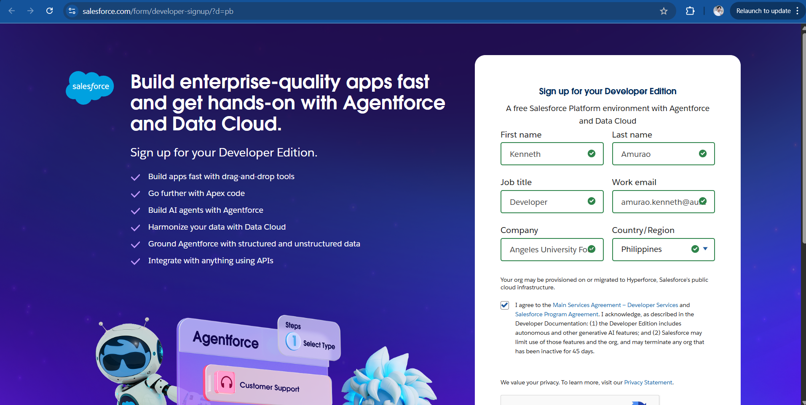

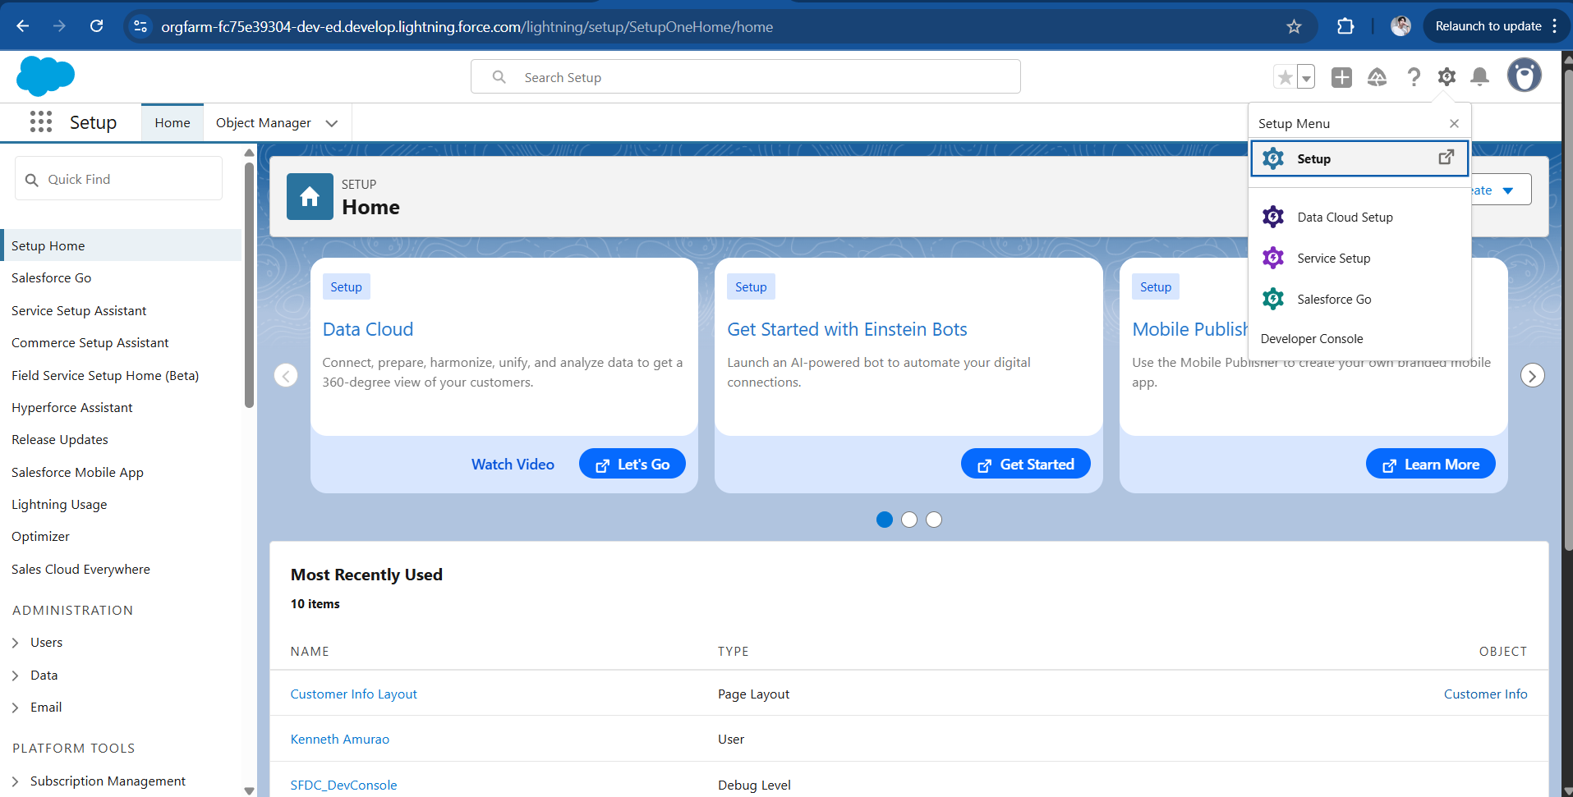

### **Customizations Implemented**

* **Seven Custome Objects & Fields:** Customer__c, Booking__c, BookingGuest__c, TravelPackage__c, BookingPayment__c, Employee__c, and Feedback__c. Over 60 fields were configured across these objects, including lookups, picklists, formula fields, and roll-up summaries.

Customer info (Object & Fields)

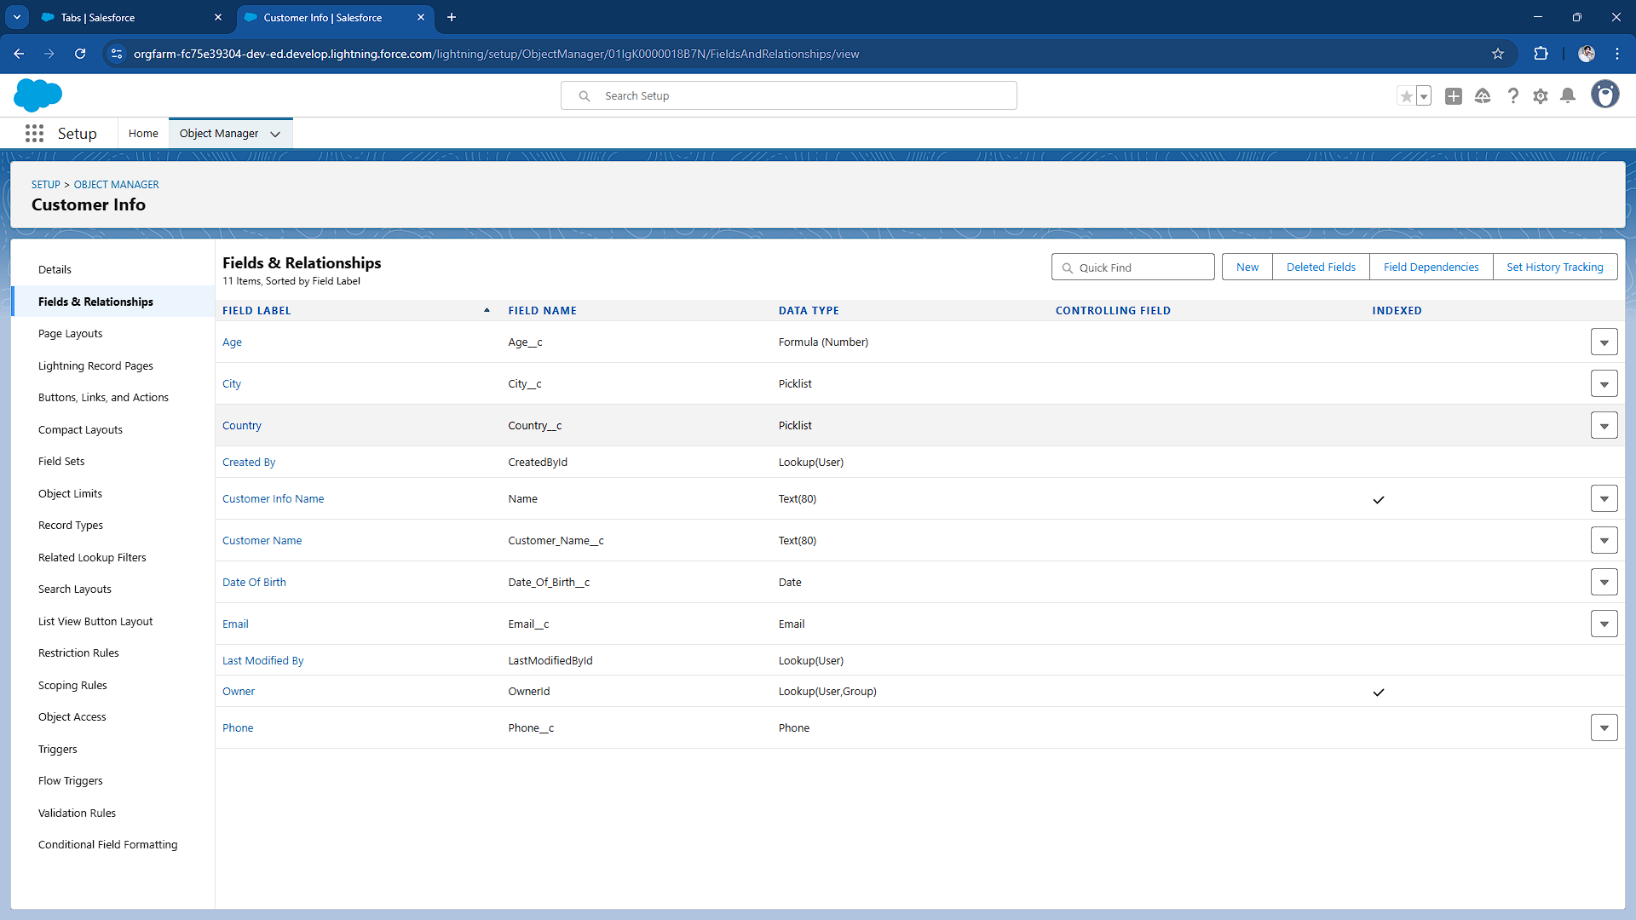

BookingGuest (Object & Fields)

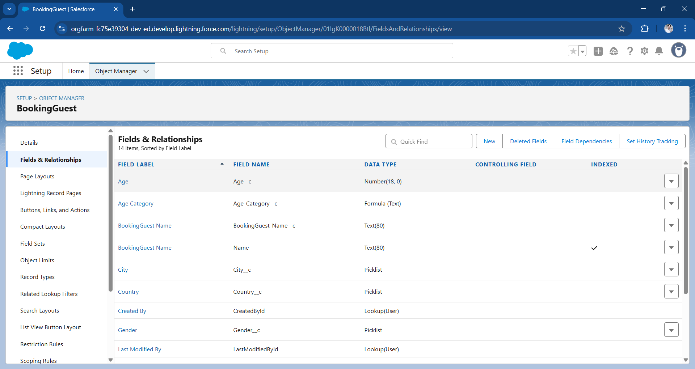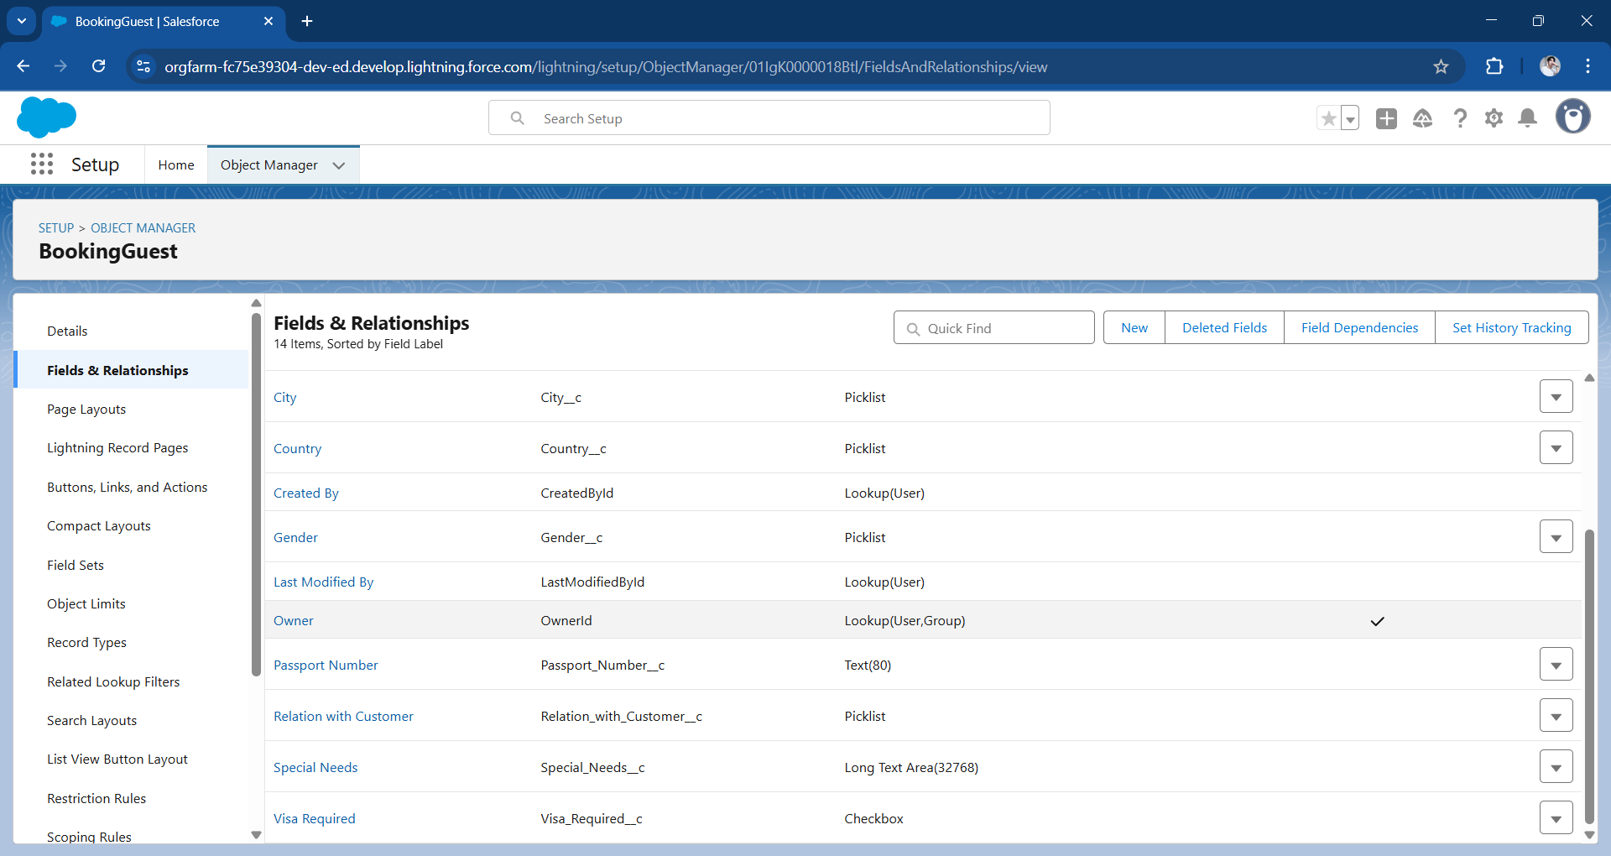

Booking (Object & Fields)

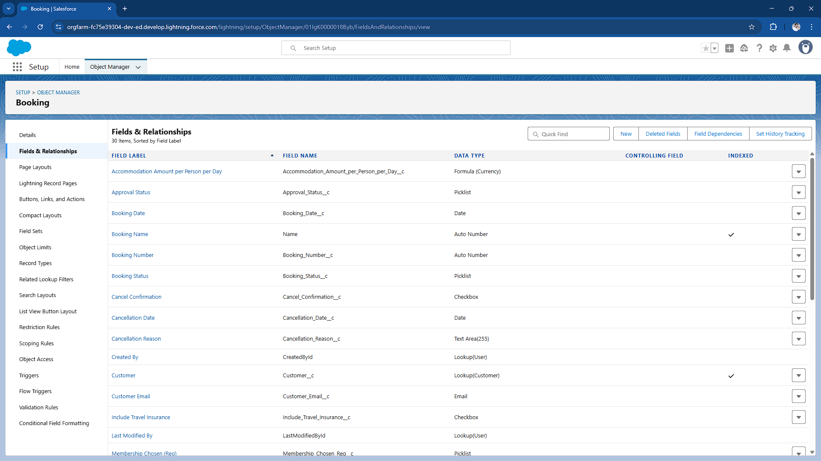

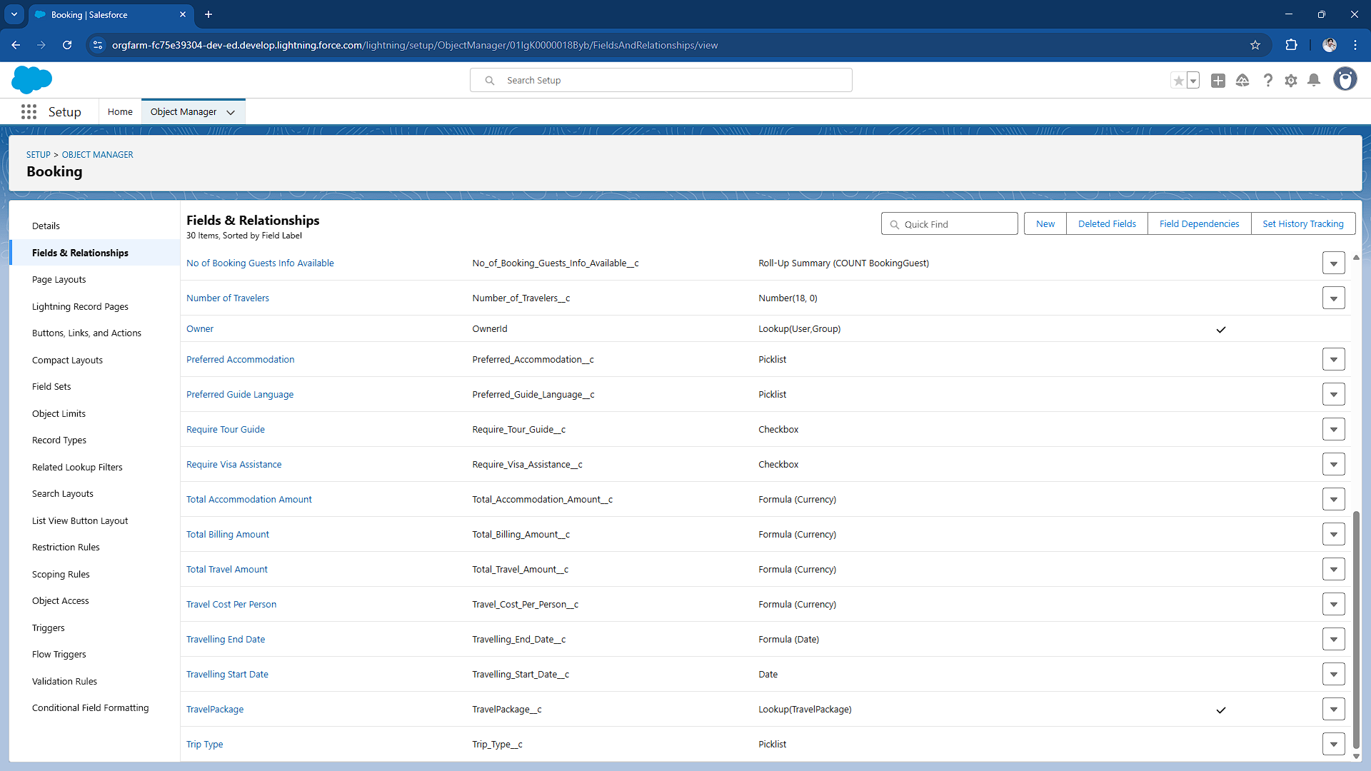

Travel Package Object (Object & Fields)

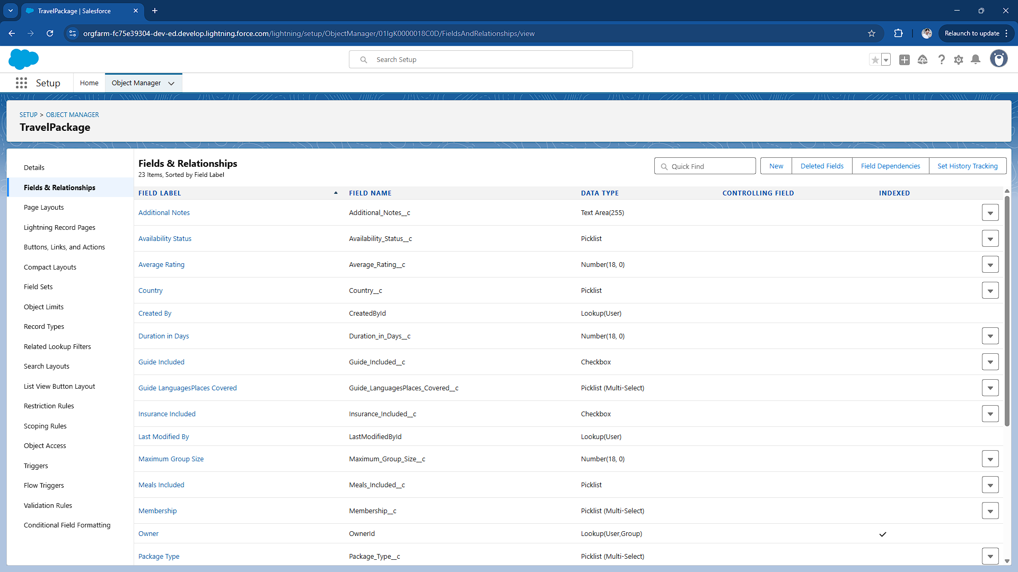

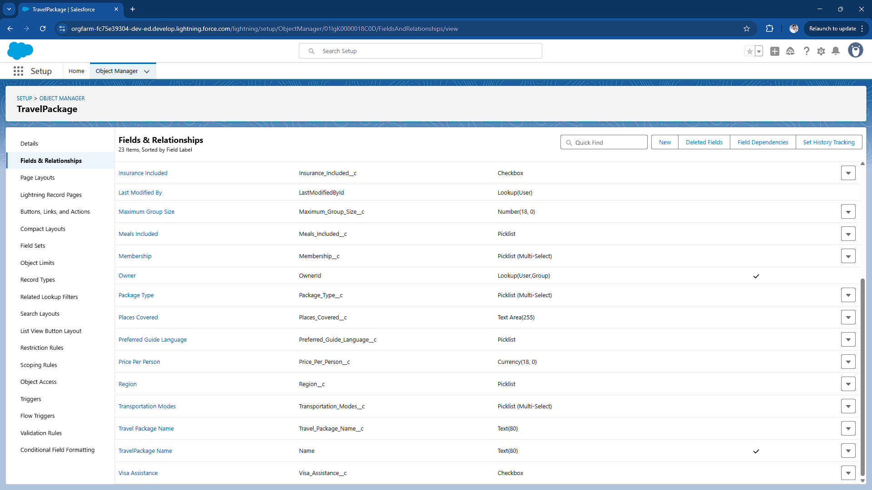

Booking Payment (Object & Fields)

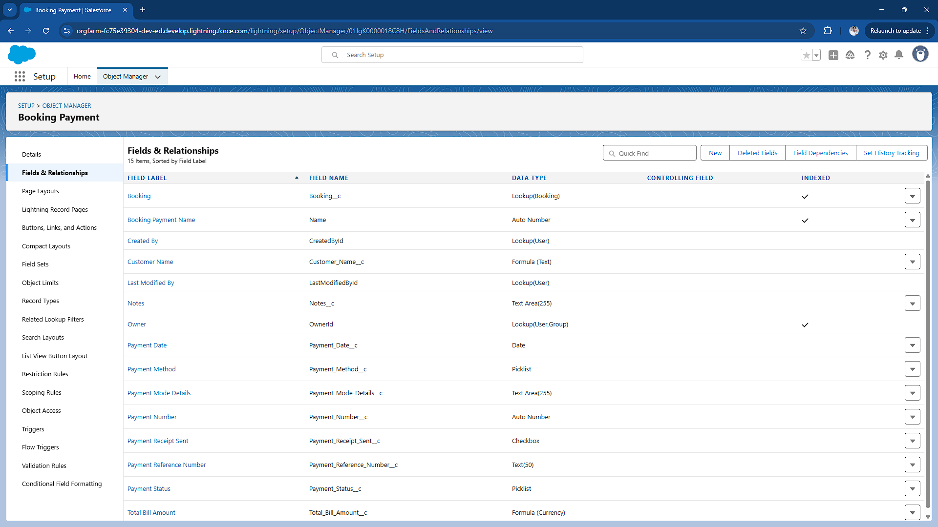

Feedback Object

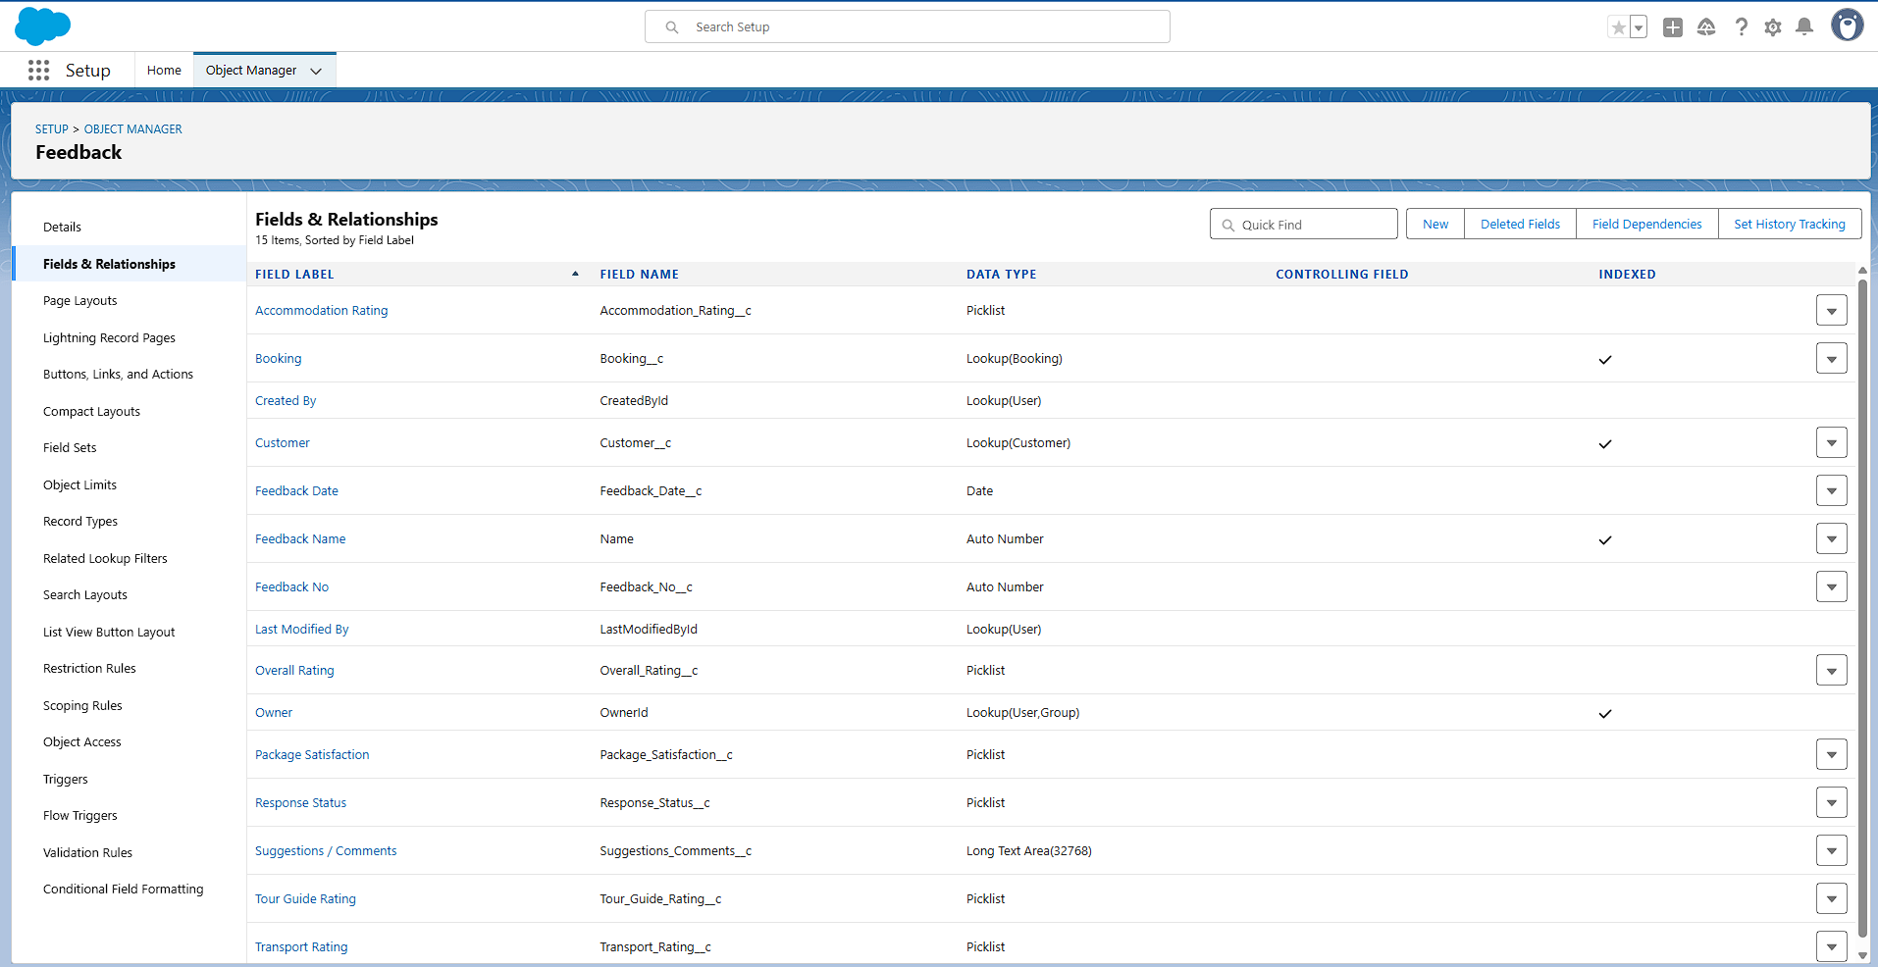

* **Validation Rules:** Ensured data accuracy (e.g., 10-digit phone, email regex).
  + Phone field must be 10 digits.(Customer Info, BookingGuest

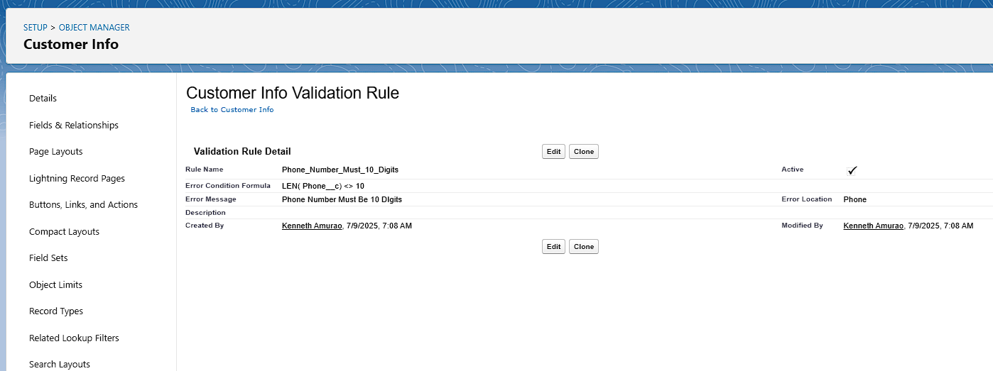

* + The email must match the standard email format.

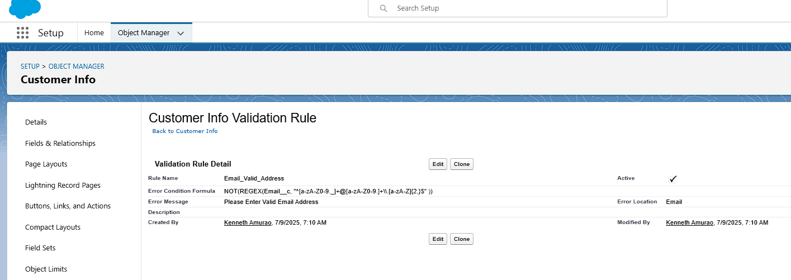

* + Date of Birth must not be in the future. (Customer Info)

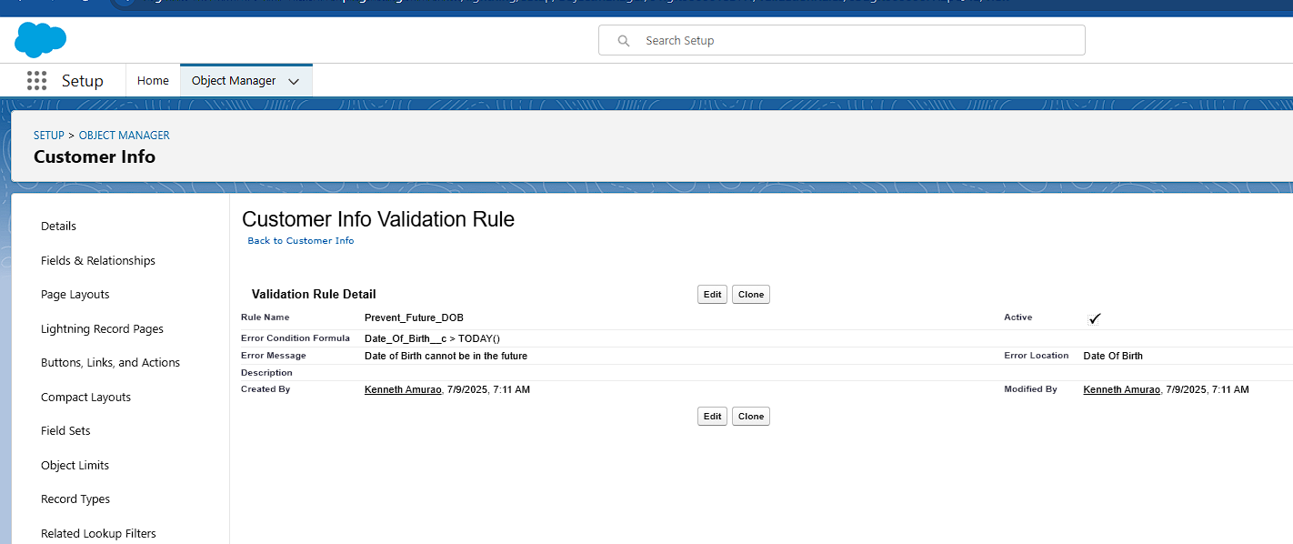

* + Mandatory Email and Language Spoken( Employee)

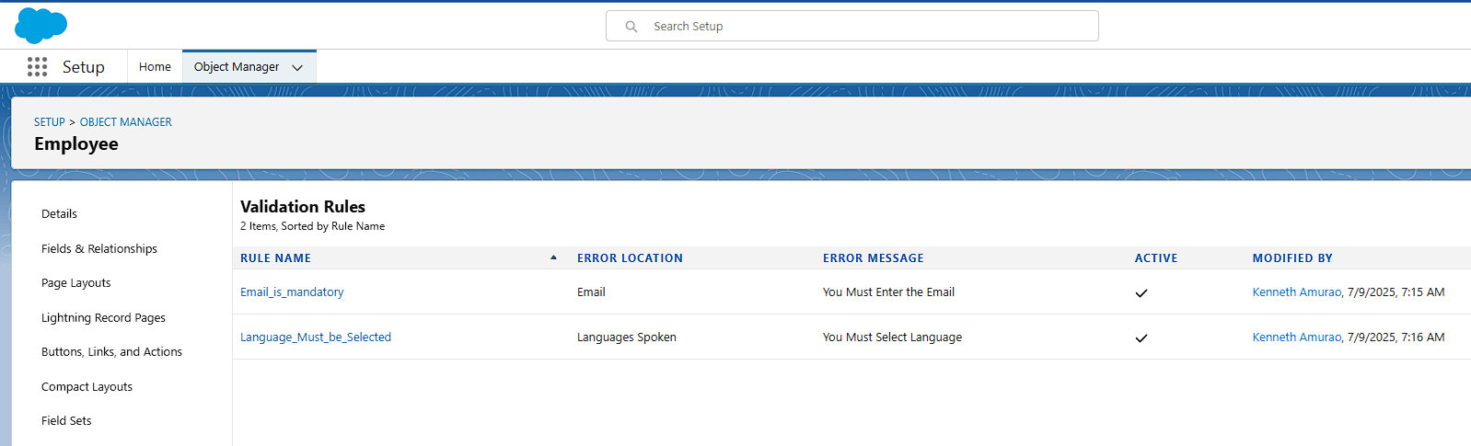

* **Automation Tools:**
  + **Flows:** A flow was built to prevent adding more guests than travelers in a booking. Another flow handled error messages for violations.

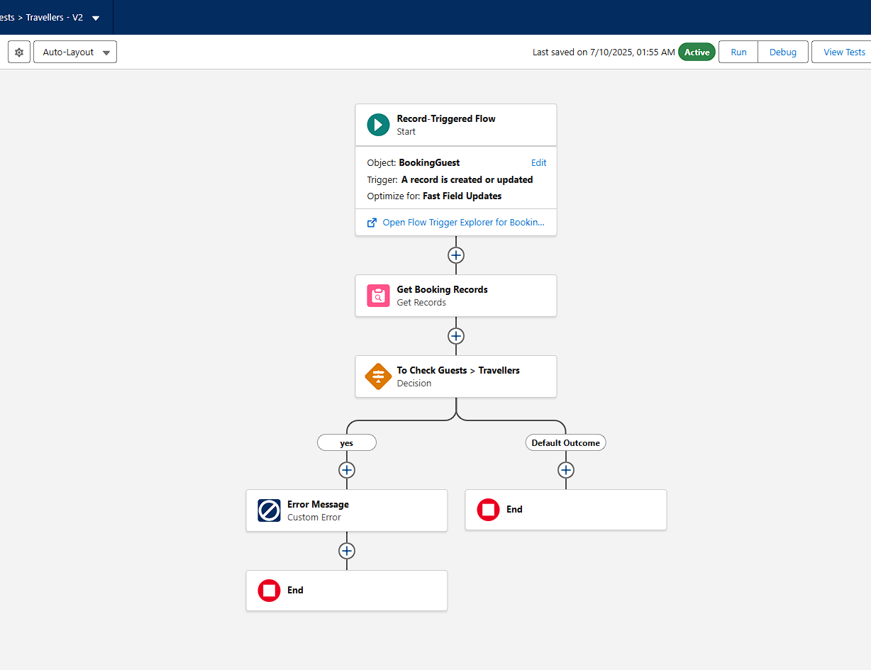

* + **Workflow Rule:** Automatically assigned a follow-up Task to the Travel Agent three days after the trip's end.

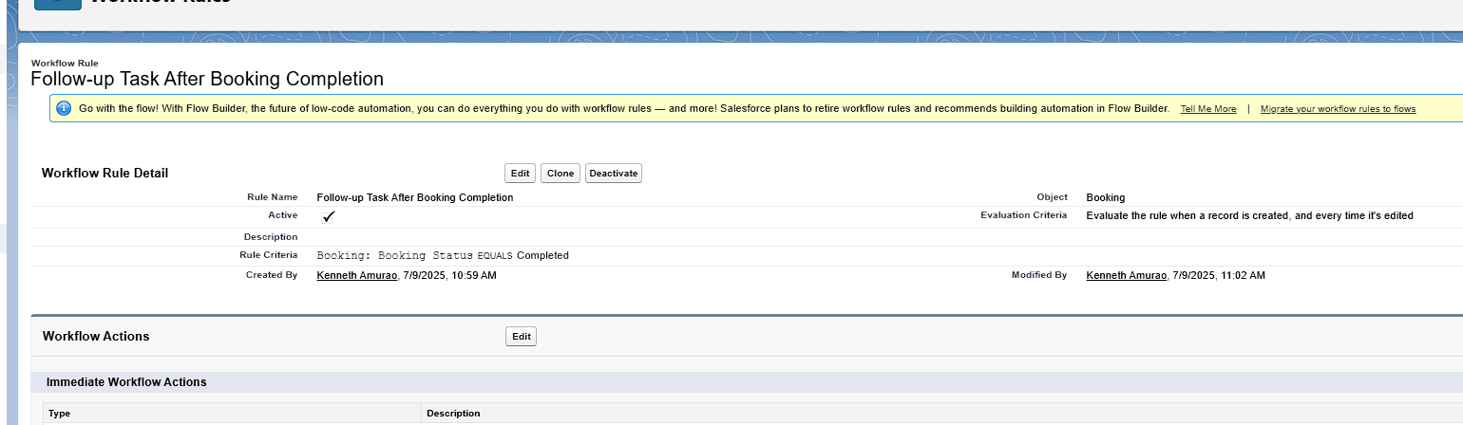

* + **Process Builder:** Automatically updated Booking Status to "Confirmed" when payment status became "Completed".

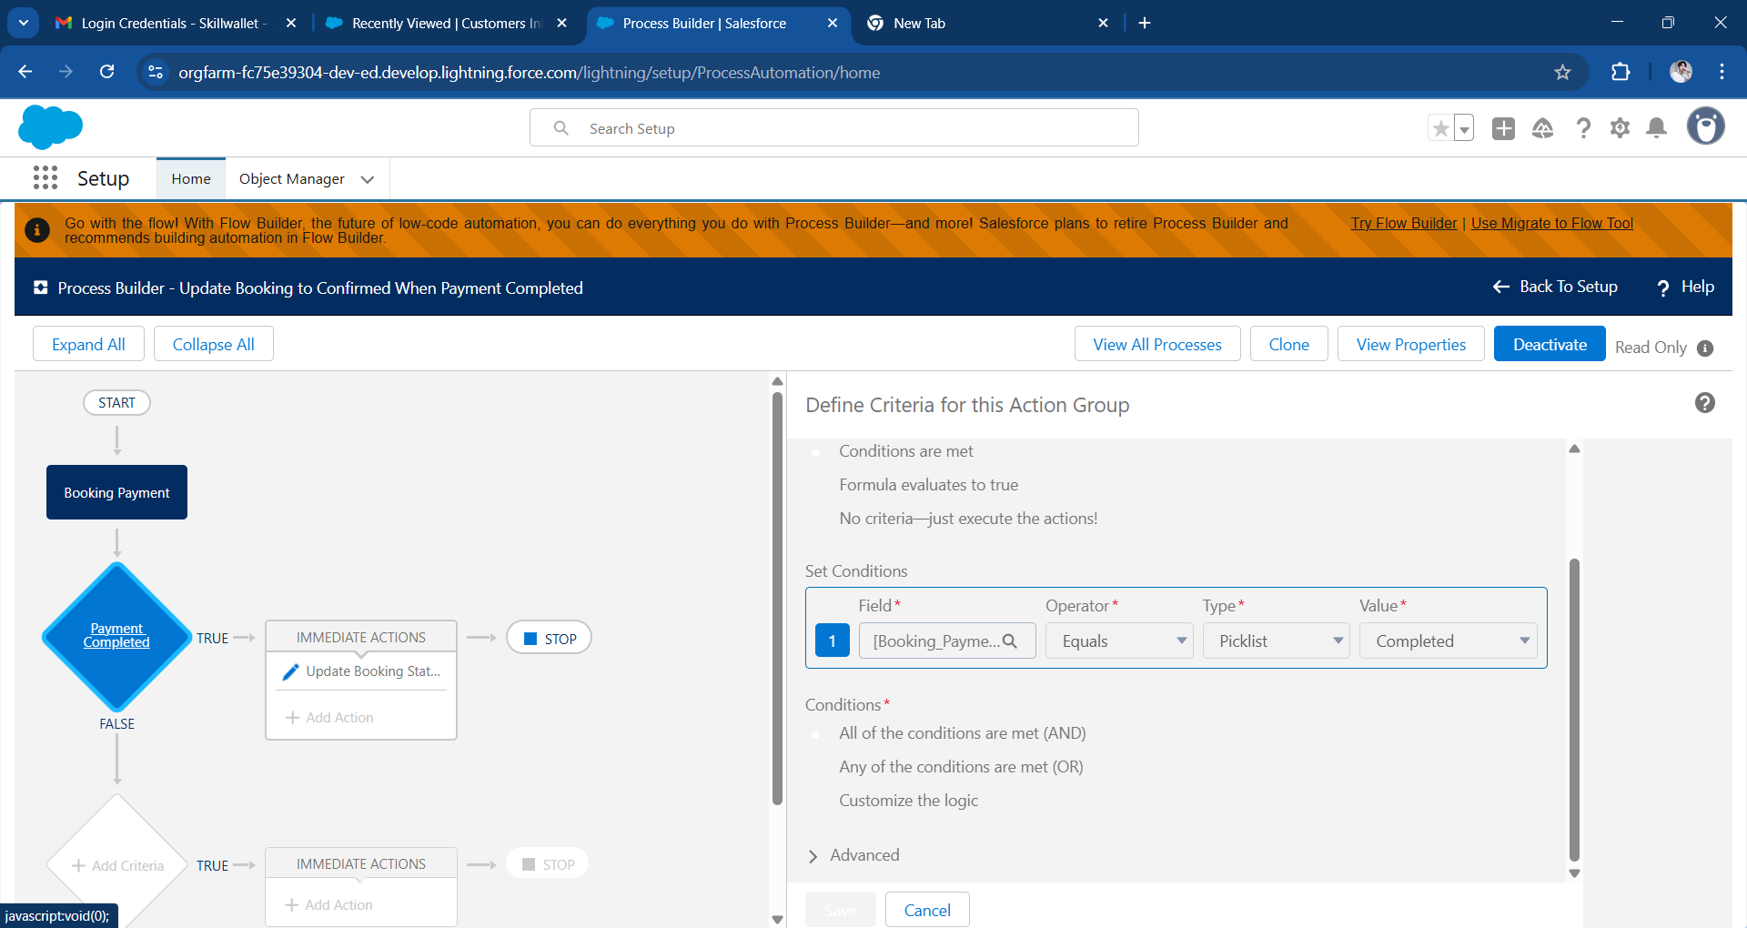

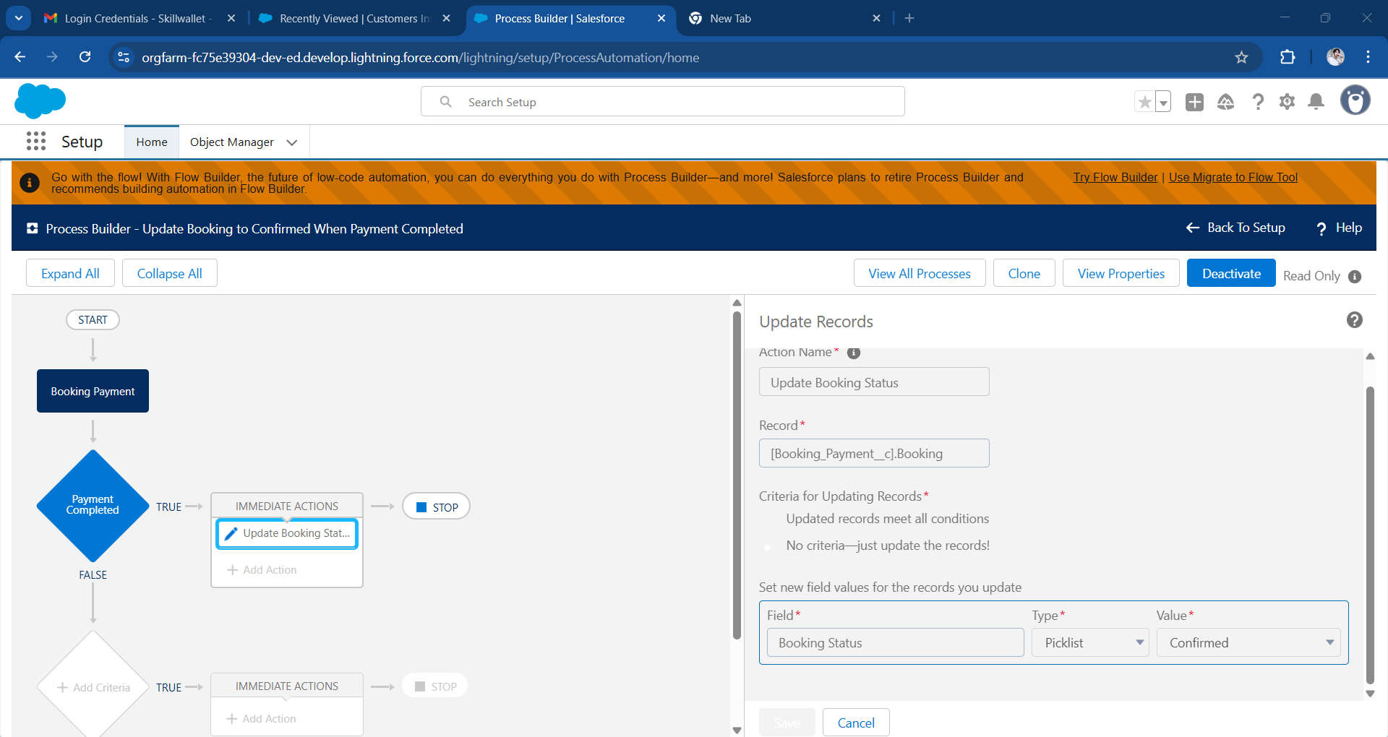

* + **Approval Process:** Canceled bookings required manager approval, triggering approval emails and status updates based on the outcome.

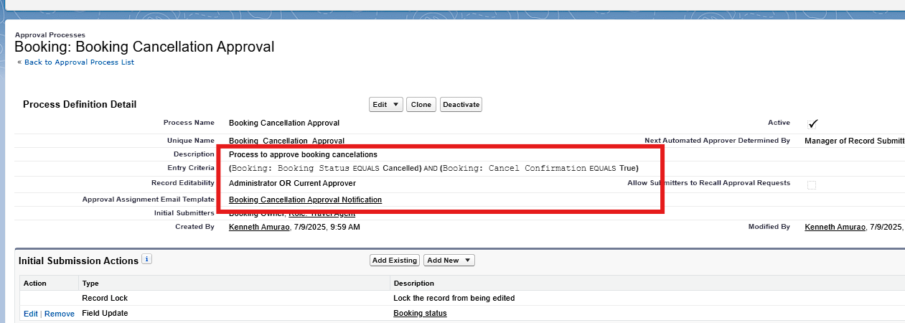

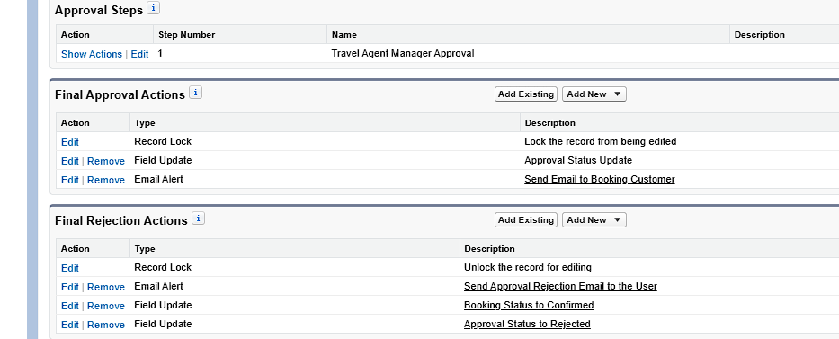

### 

### **Apex Development**

* **Trigger:** A trigger on the Booking__c object created BookingPayment__c and BookingGuest__c records automatically when a booking was inserted.

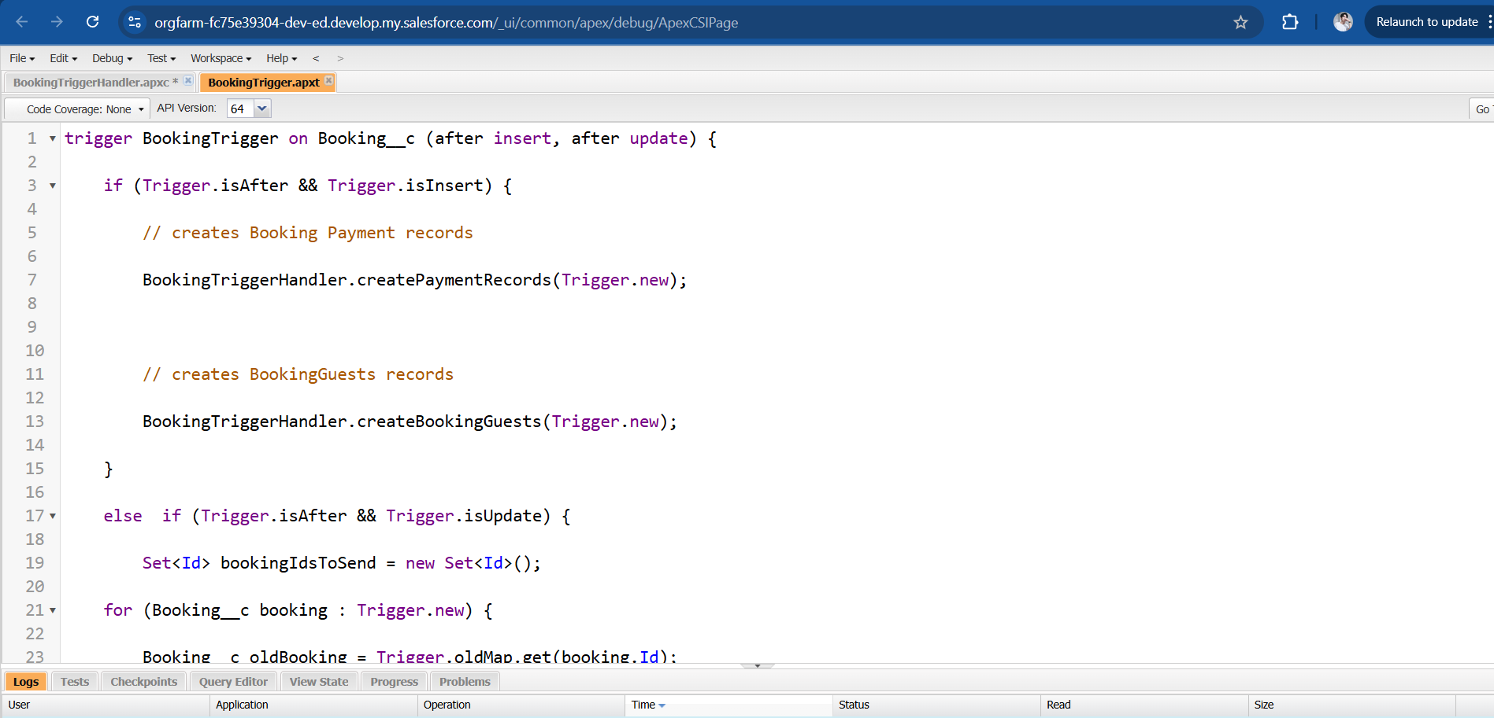

* **Apex Class:** The logic was abstracted into BookingTriggerHandler class for modularity and reusability.

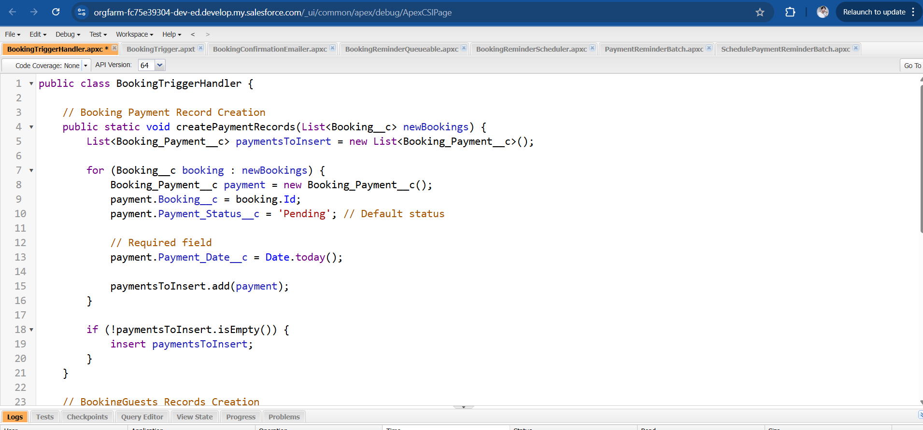

* **Asynchronous Apex:**
  + **Future Method:** This method was used to send booking confirmation emails after the booking status was updated to "Confirmed."

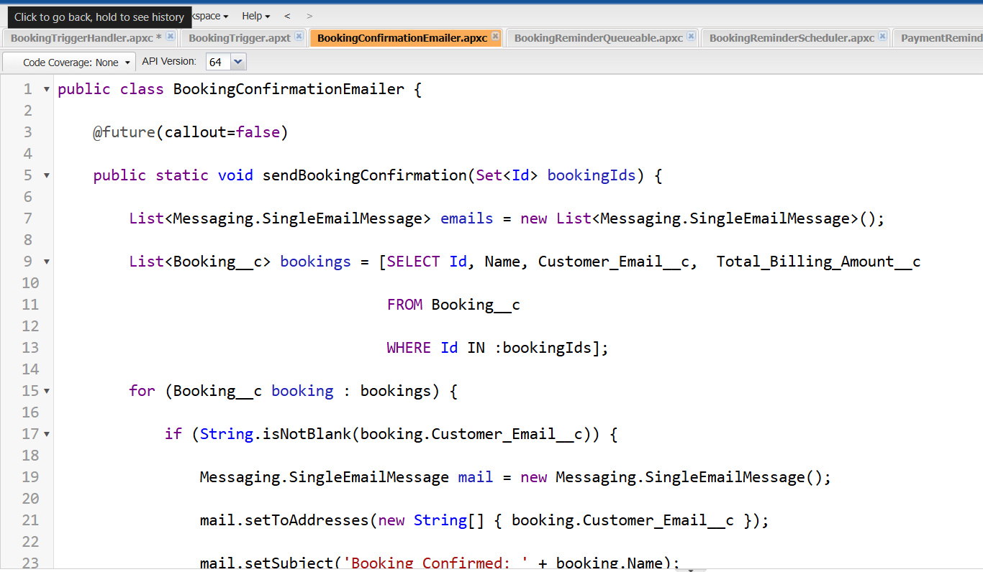

* + **Queueable Class:** A queueable class was created to handle the logic of sending personalized reminder emails to customers exactly 3 days before their tour starts.

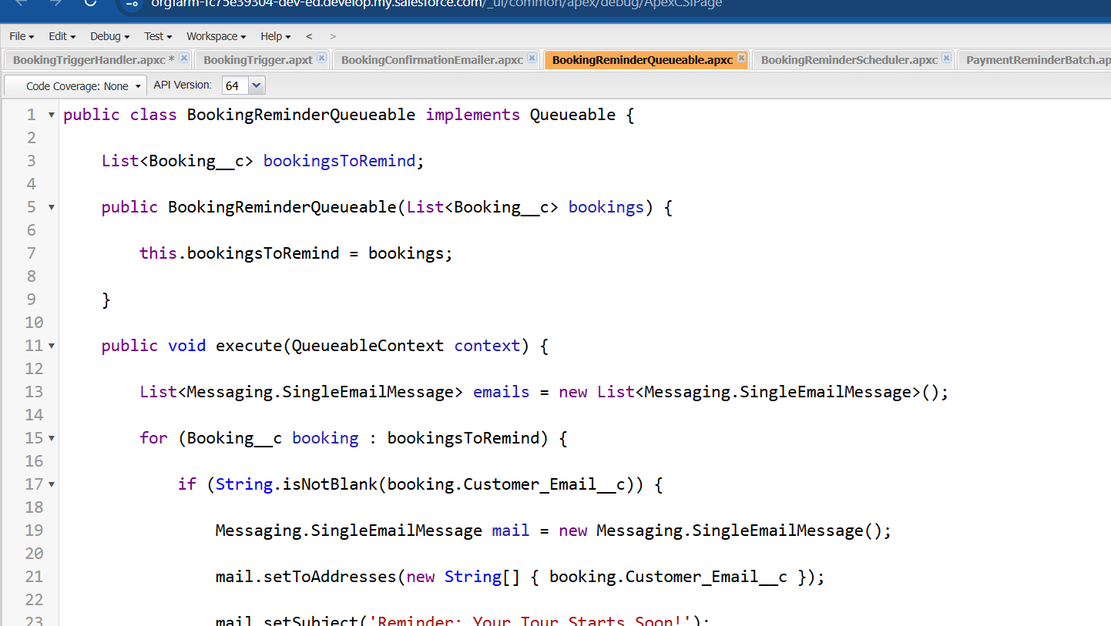

* + **Batch Class:** Daily payment reminder emails. A batch job was implemented to send payment reminders on a daily basis. It queried bookings with a 'Pending' payment status and emailed the respective customers.

## 

* + **Schedulable Apex:** Scheduled jobs for automation.

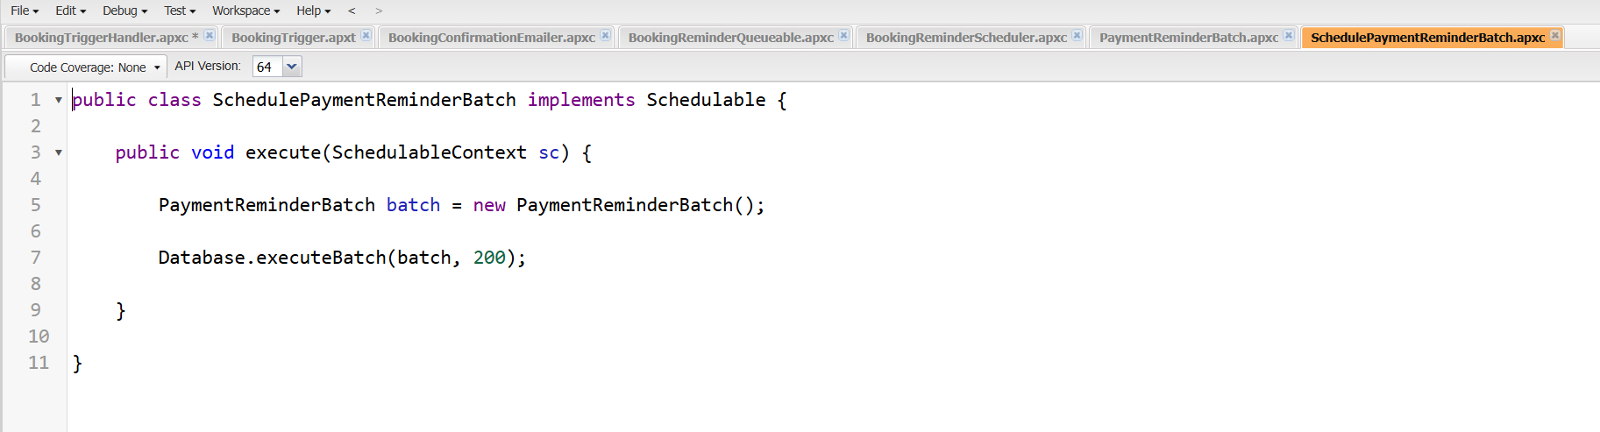

## 

## 

## 

## **Phase 3: UI/UX Development & Customization**

### **Lightning App Setup**

A custom app named **"Tours & Travels CRM"** was built using the **App Manager** in Salesforce Lightning. This app centralized access to all CRM components such as Customer Info, Bookings, Payments, Employees, and more.

* Tabs were organized for ease of navigation: Customer, Booking, TravelPackage, Employee, Feedback, Payment, Task, Reports, and Dashboard.

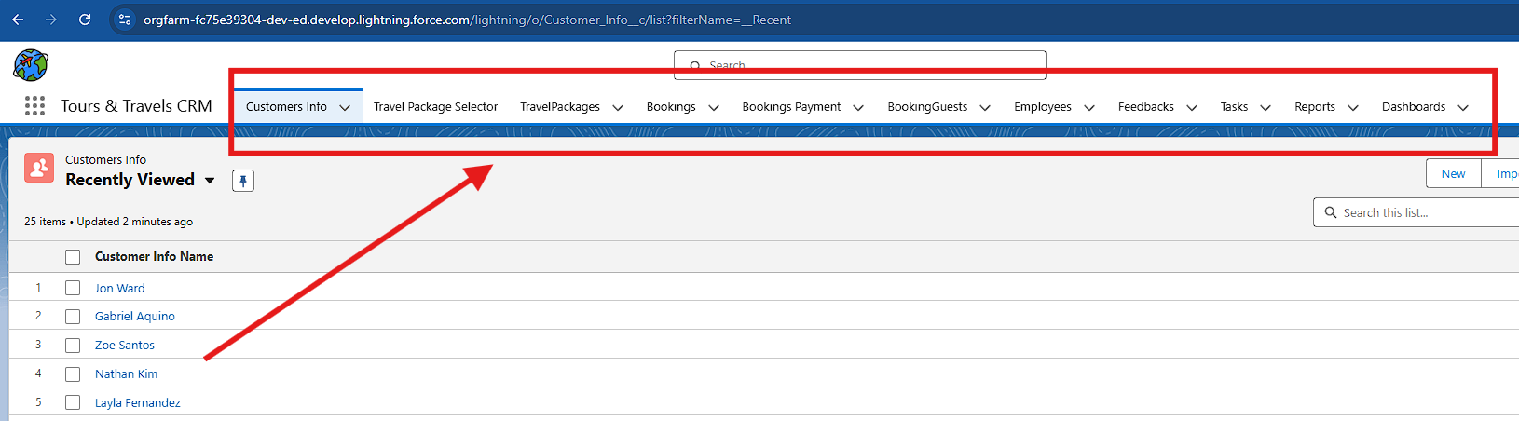

### **UI Elements**

#### **Page Layouts**

Customized layouts were created for each object to improve data visibility and user productivity. Key fields were rearranged logically to streamline user data entry and reduce cognitive load. (Customer Info, BookingGuest, TravelGuest, Employee, Booking, Booking Payment, Feedback)

Customer Info

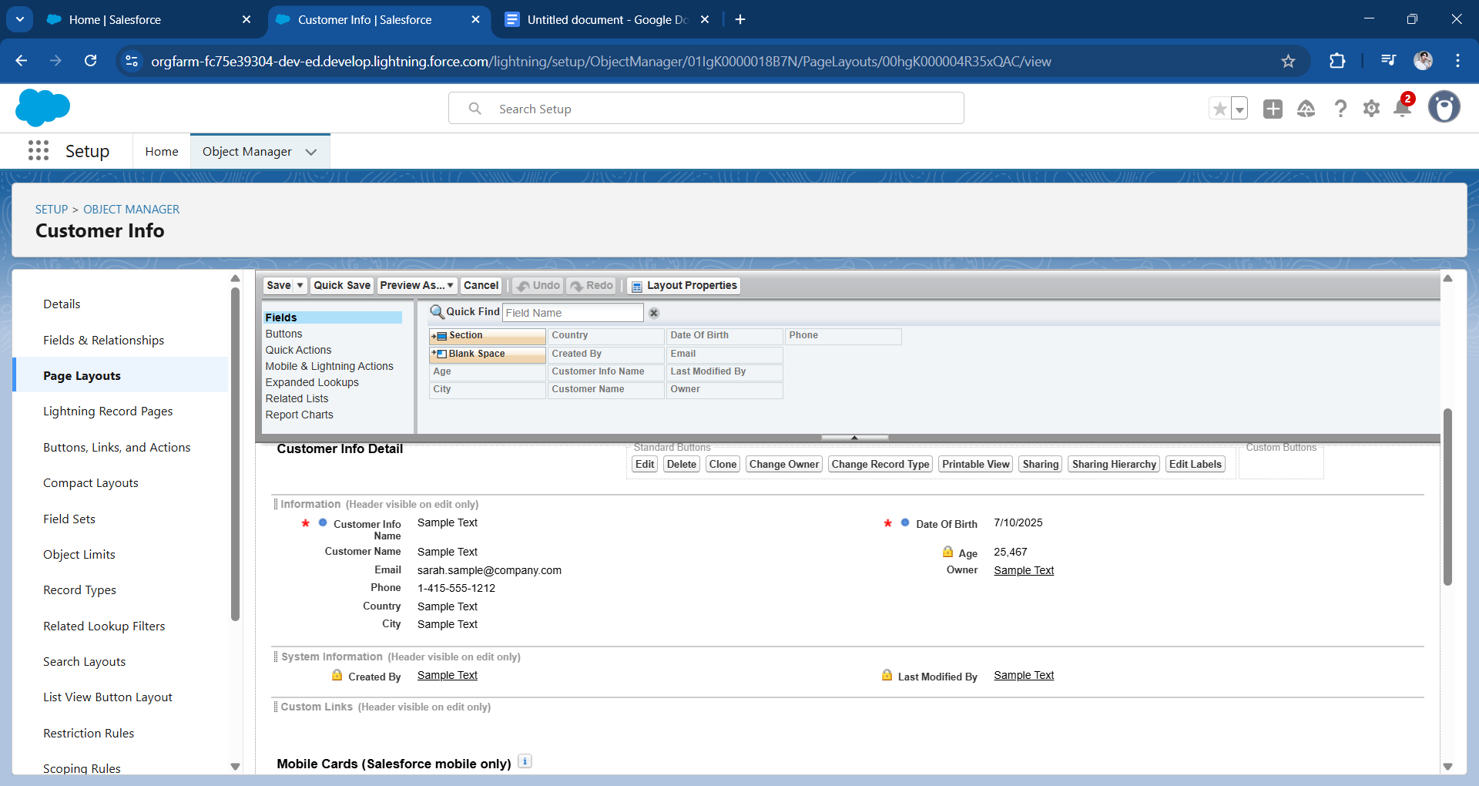

BookingGuest

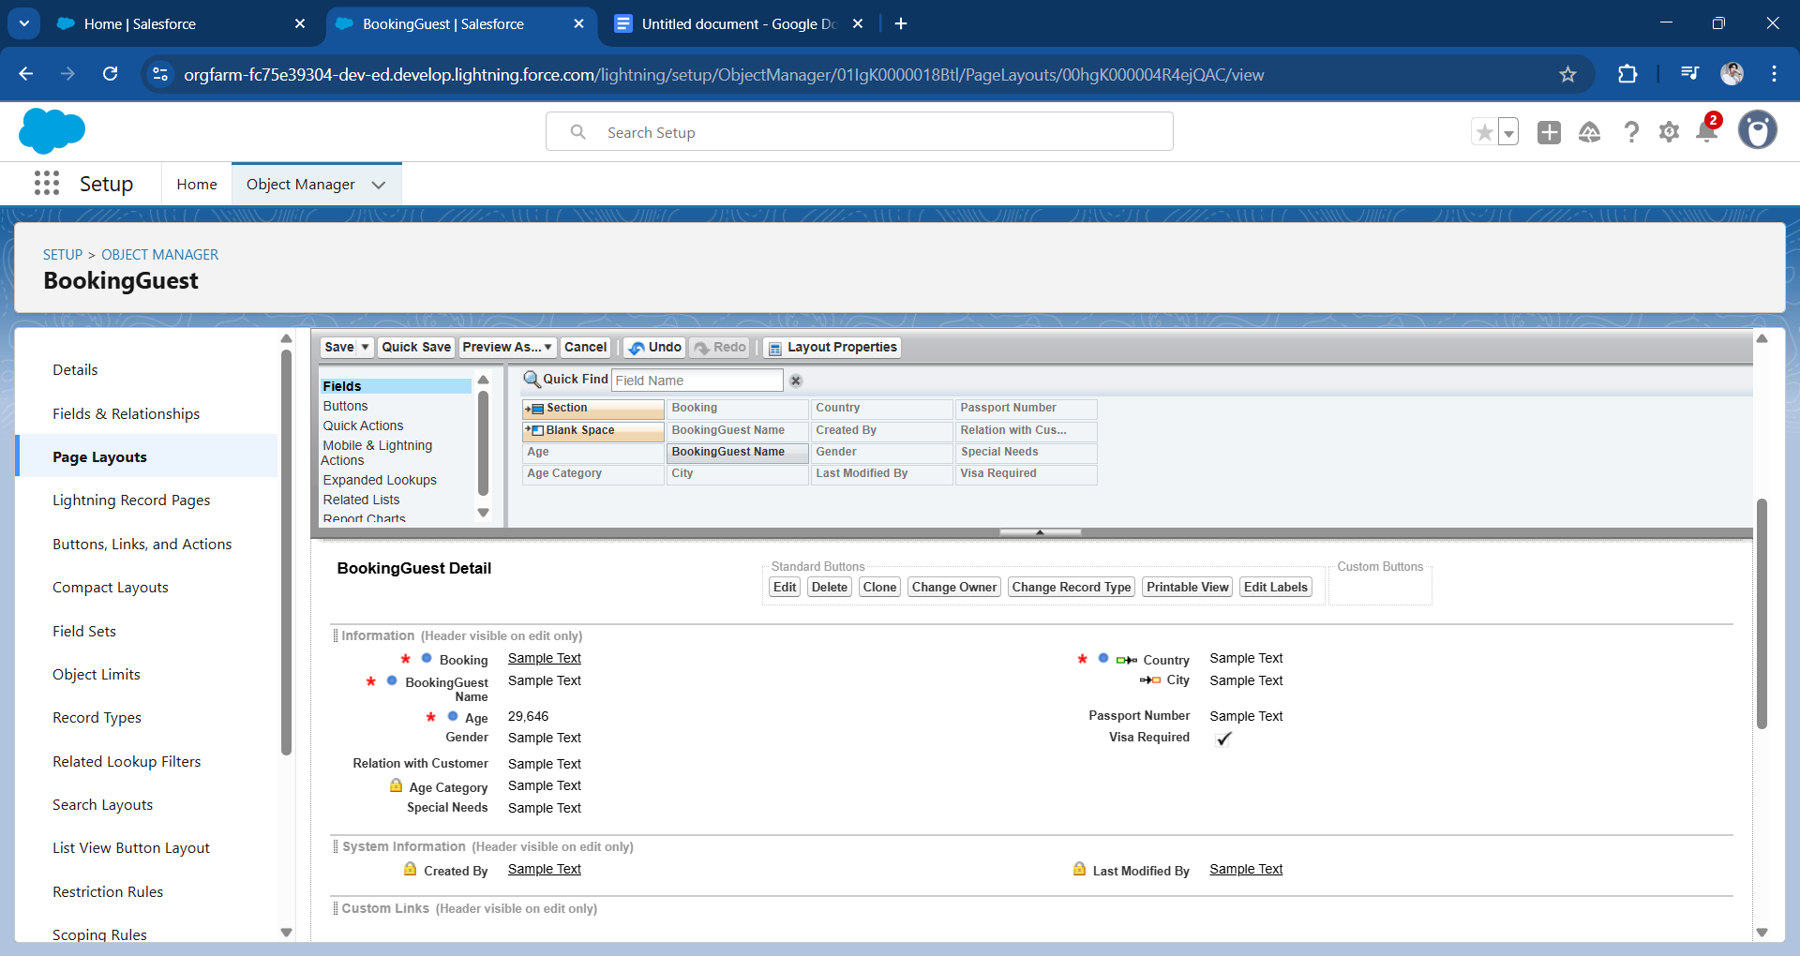

TravelGuest

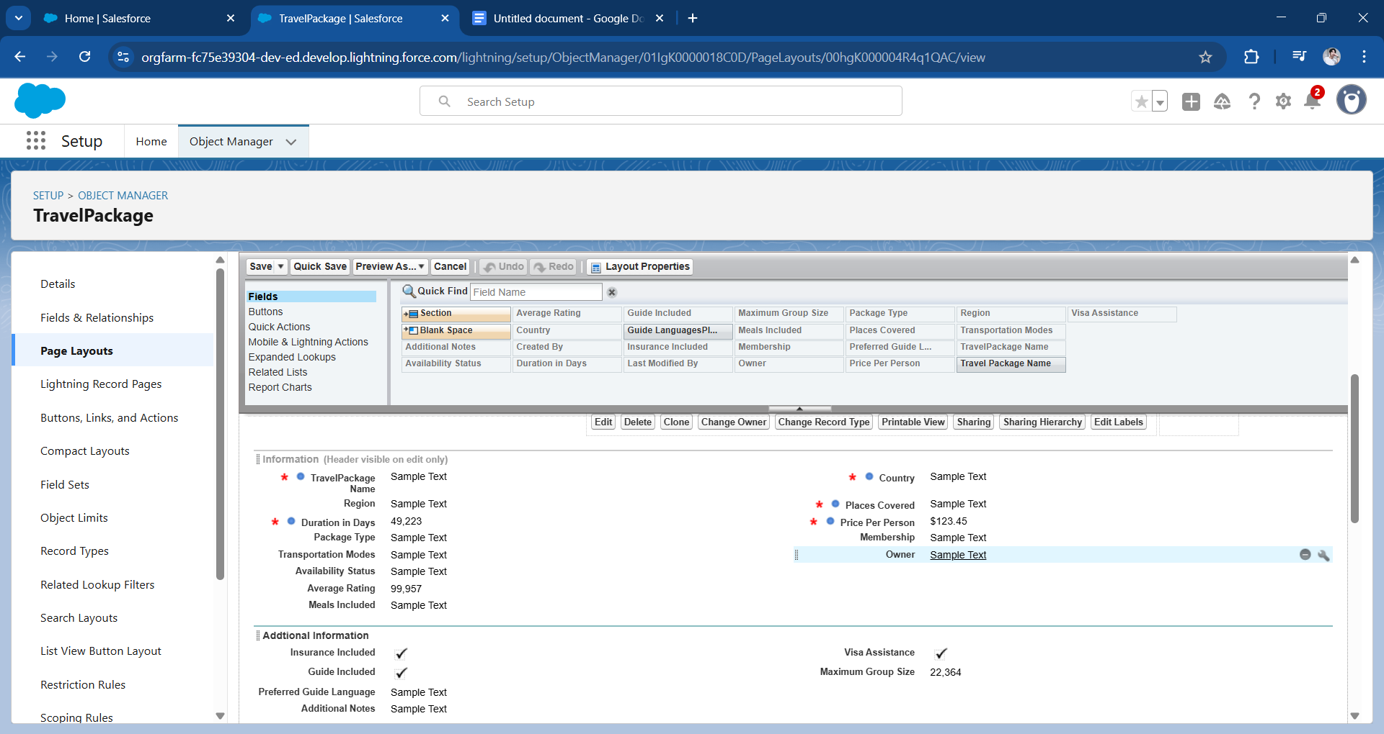

Employee

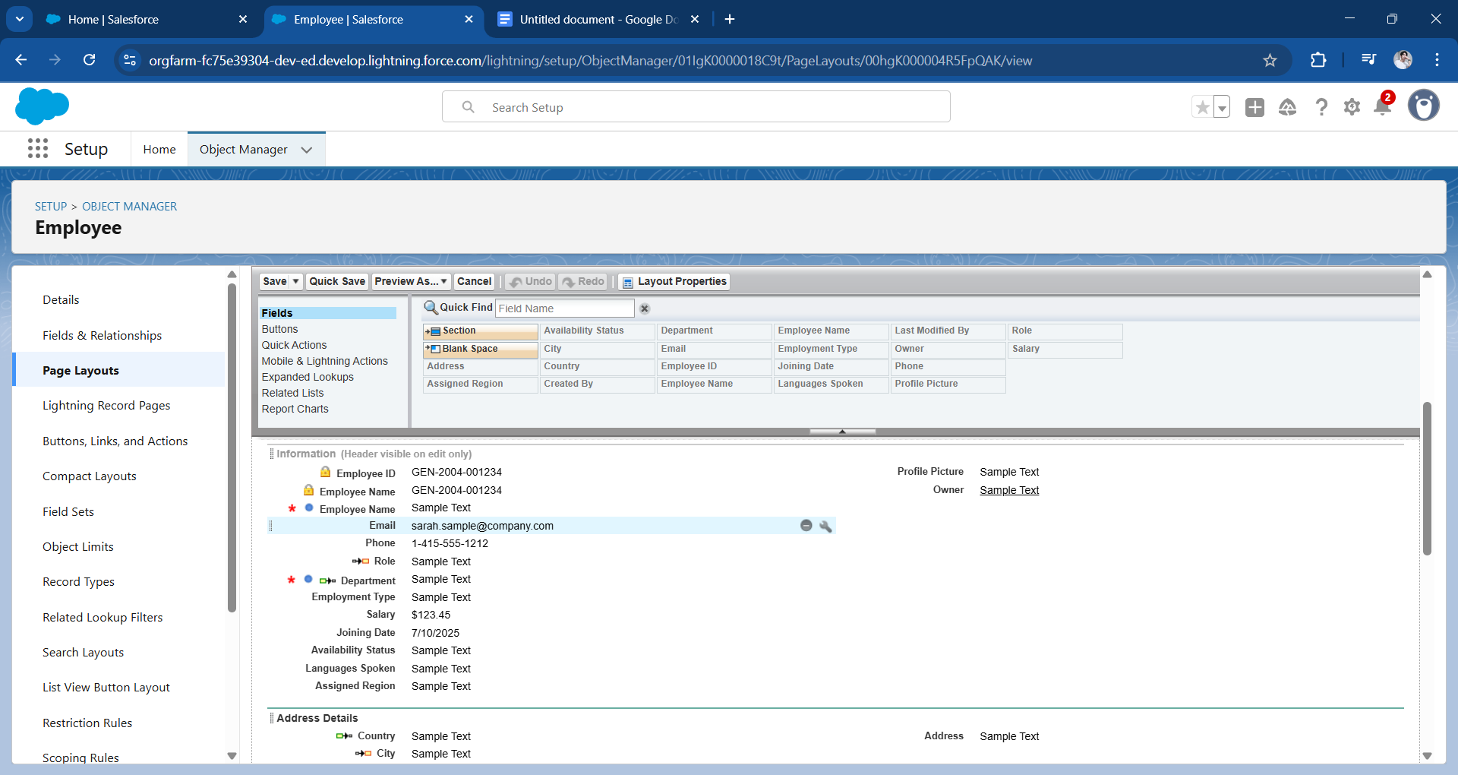

Booking

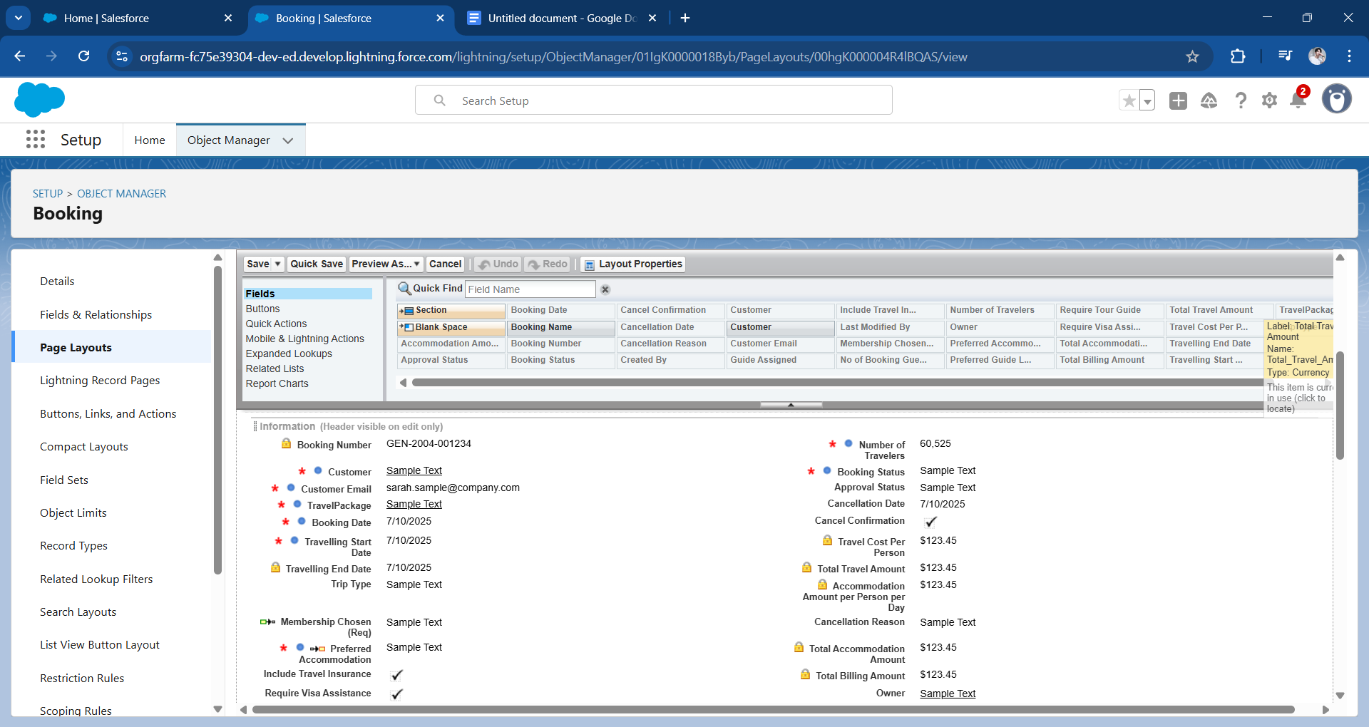

Booking Payment

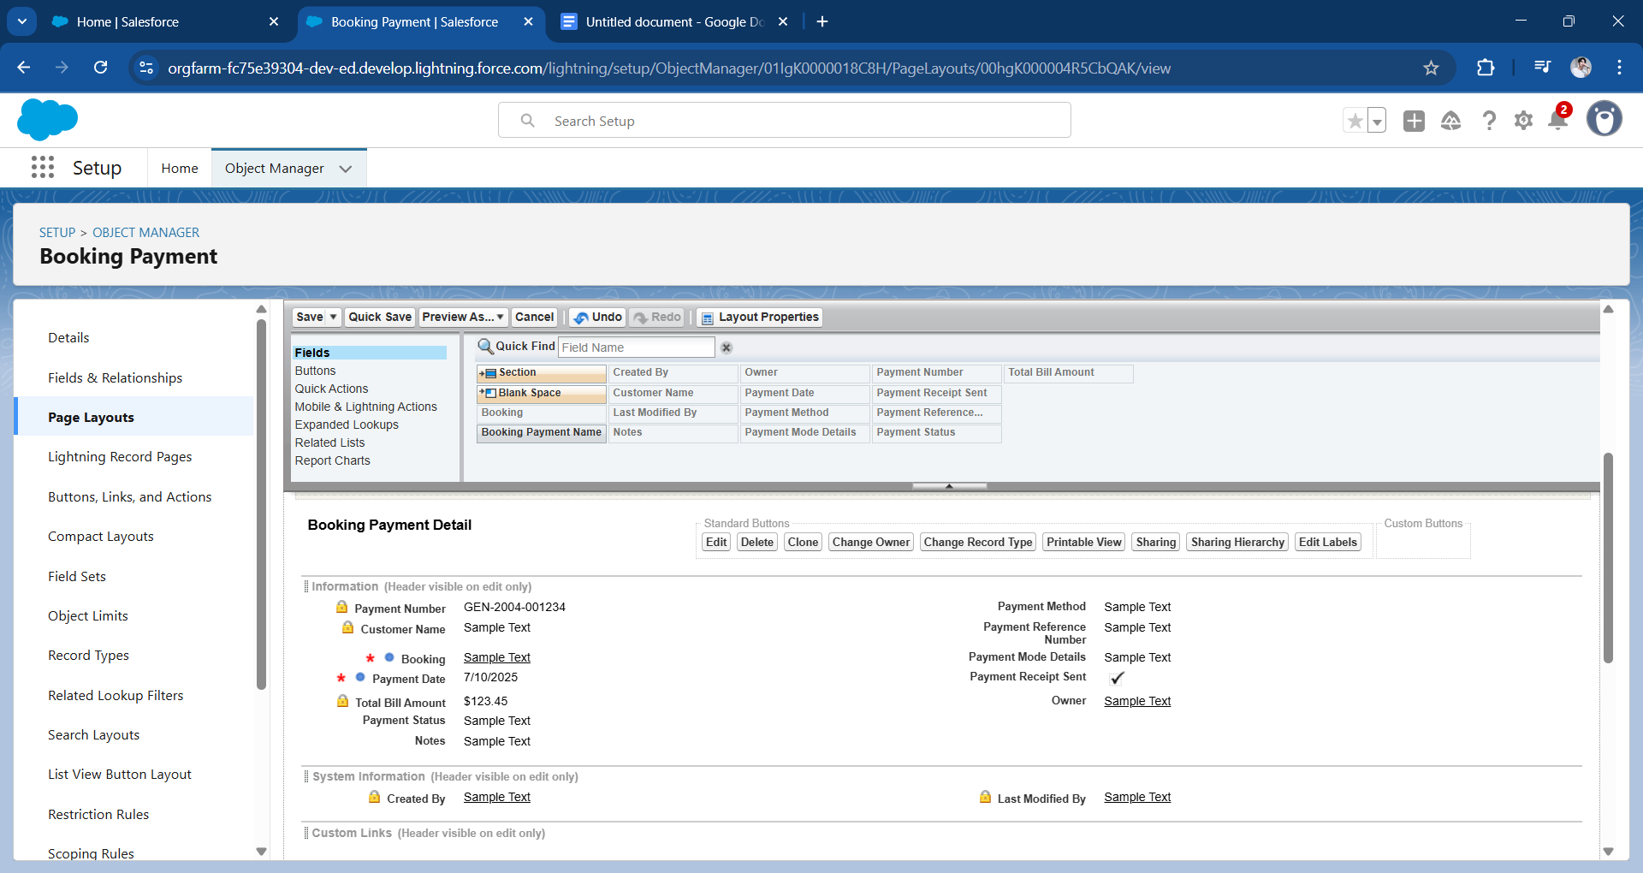

Feedback

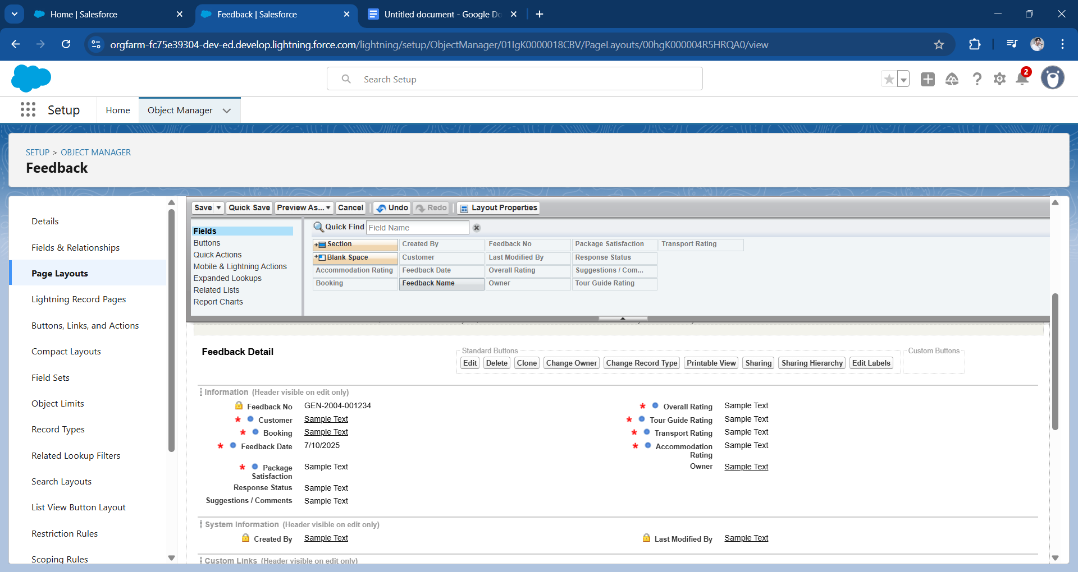

#### **Dynamic Forms**

Dynamic Forms were enabled for the Booking object to show or hide fields based on conditions. For instance, cancellation-related fields only appear when the booking status is set to “Cancelled”.

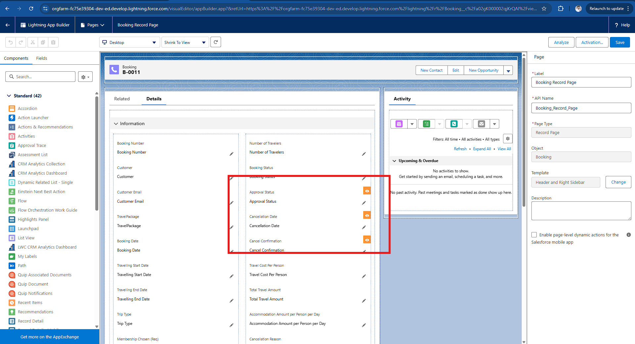

#### 

#### 

#### 

#### 

#### 

#### 

#### 

#### 

#### **Lightning Pages**

Lightning Record Pages were customized to display key information, related lists, charts, and LWCs. This provided users with a single pane view of all essential CRM operations.

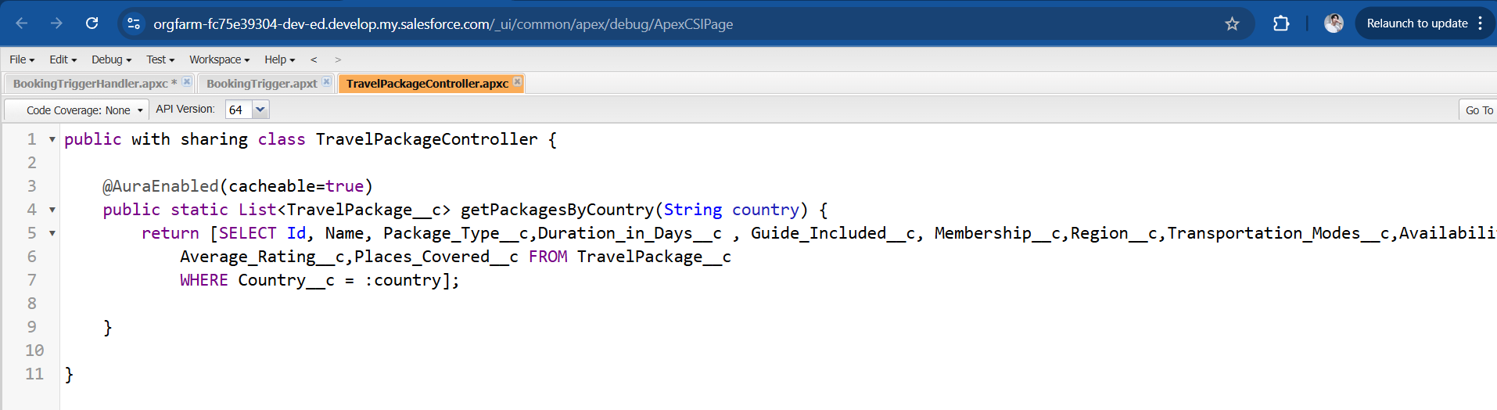

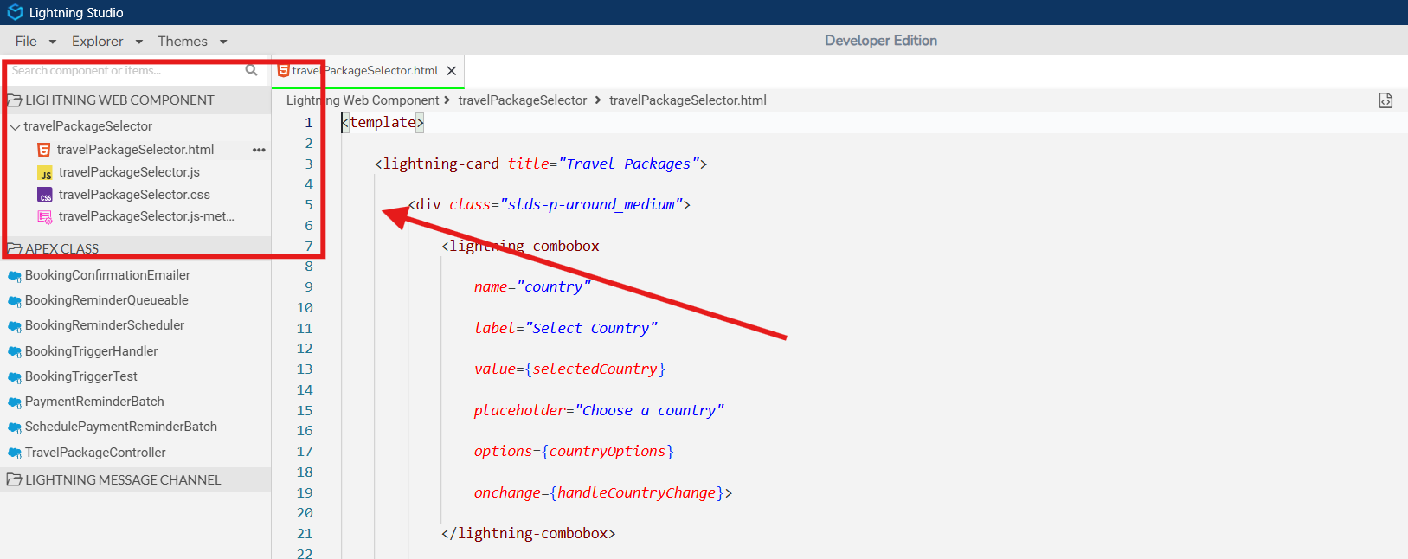

#### 

#### 

#### 

#### 

#### 

#### 

#### 

#### **Lightning Web Components (LWC)**

Developed a custom LWC named TravelPackageSelector, which filters packages by country dynamically. This component enhances user interactivity by allowing users to select packages without refreshing the page.

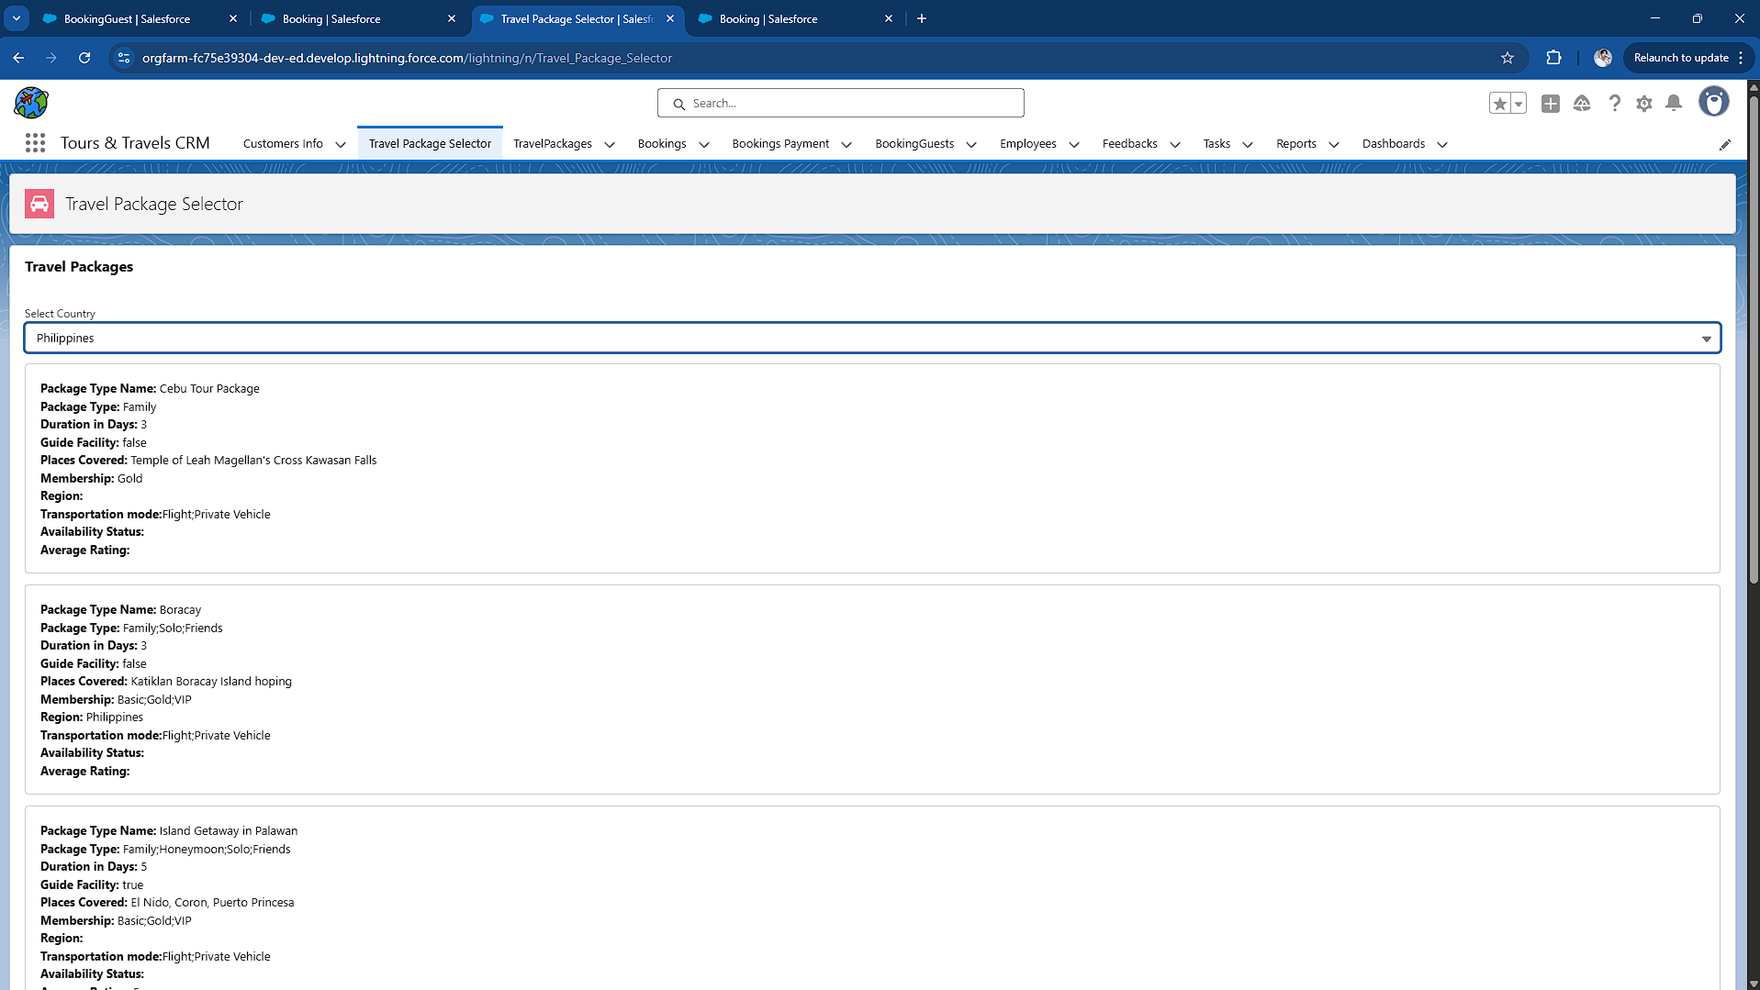

### 

### 

### 

### 

### 

### 

### **User Management**

Created users for each role (e.g., Travel Agent, Tour Guide, Finance Officer) and assigned them appropriate Profiles and Roles. This ensured secure, role-specific access throughout the CRM.

* Users created for each role (Travel Agent, Guide, Finance, Marketing Executive Profile & Customer Service Rep) cloning Standard Platform User. I set Custom Object Permission for each Profile.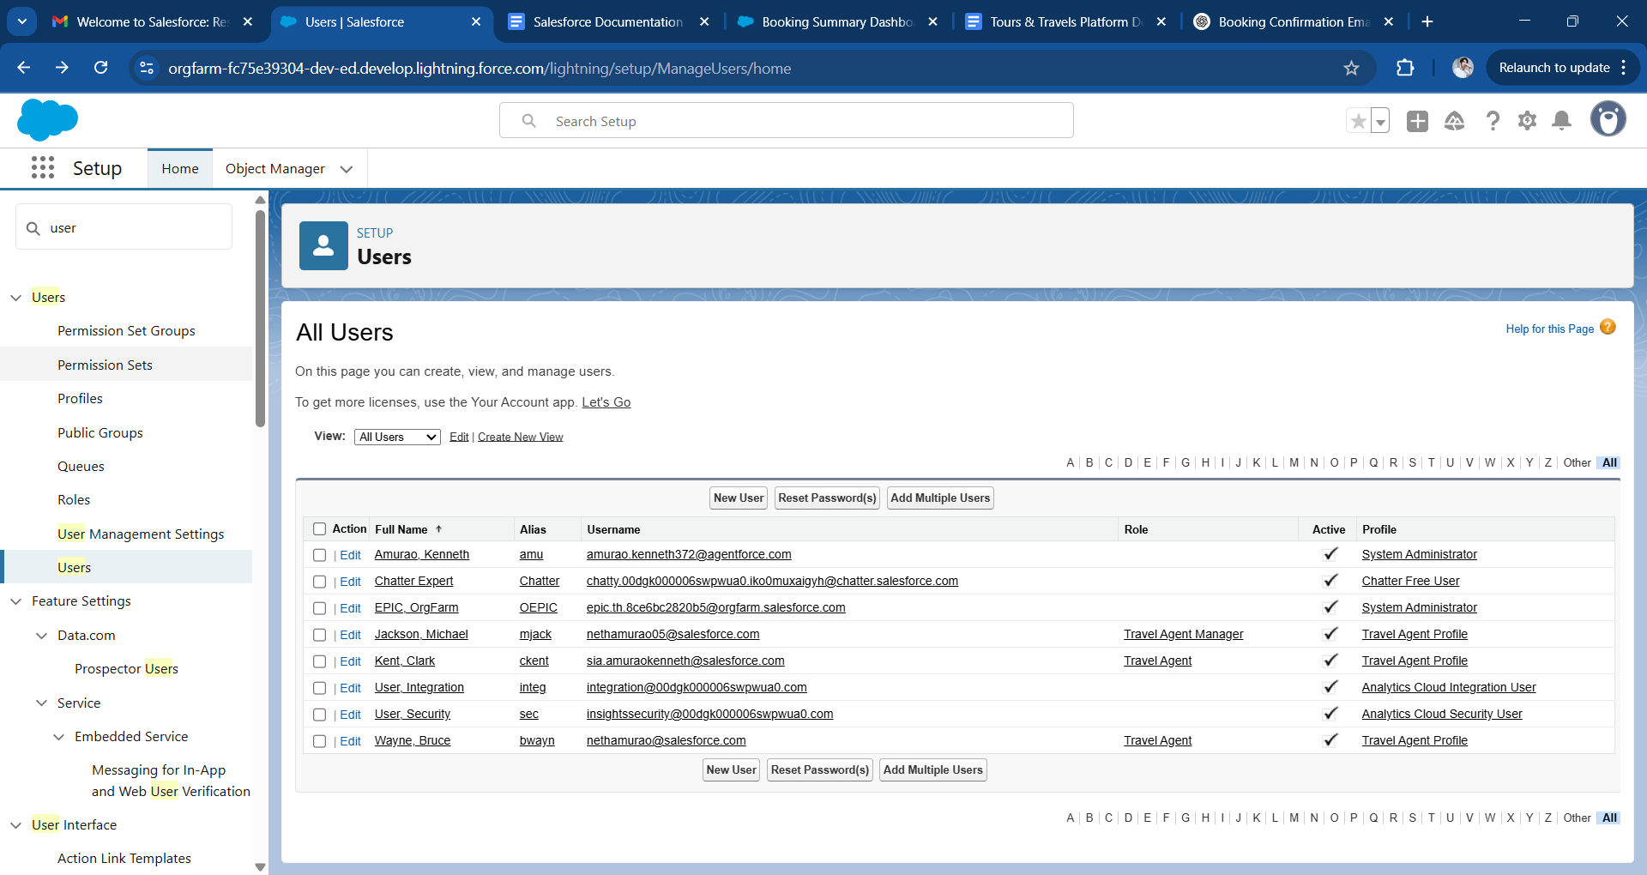
* Assigned appropriate profiles and roles to enforce hierarchy.

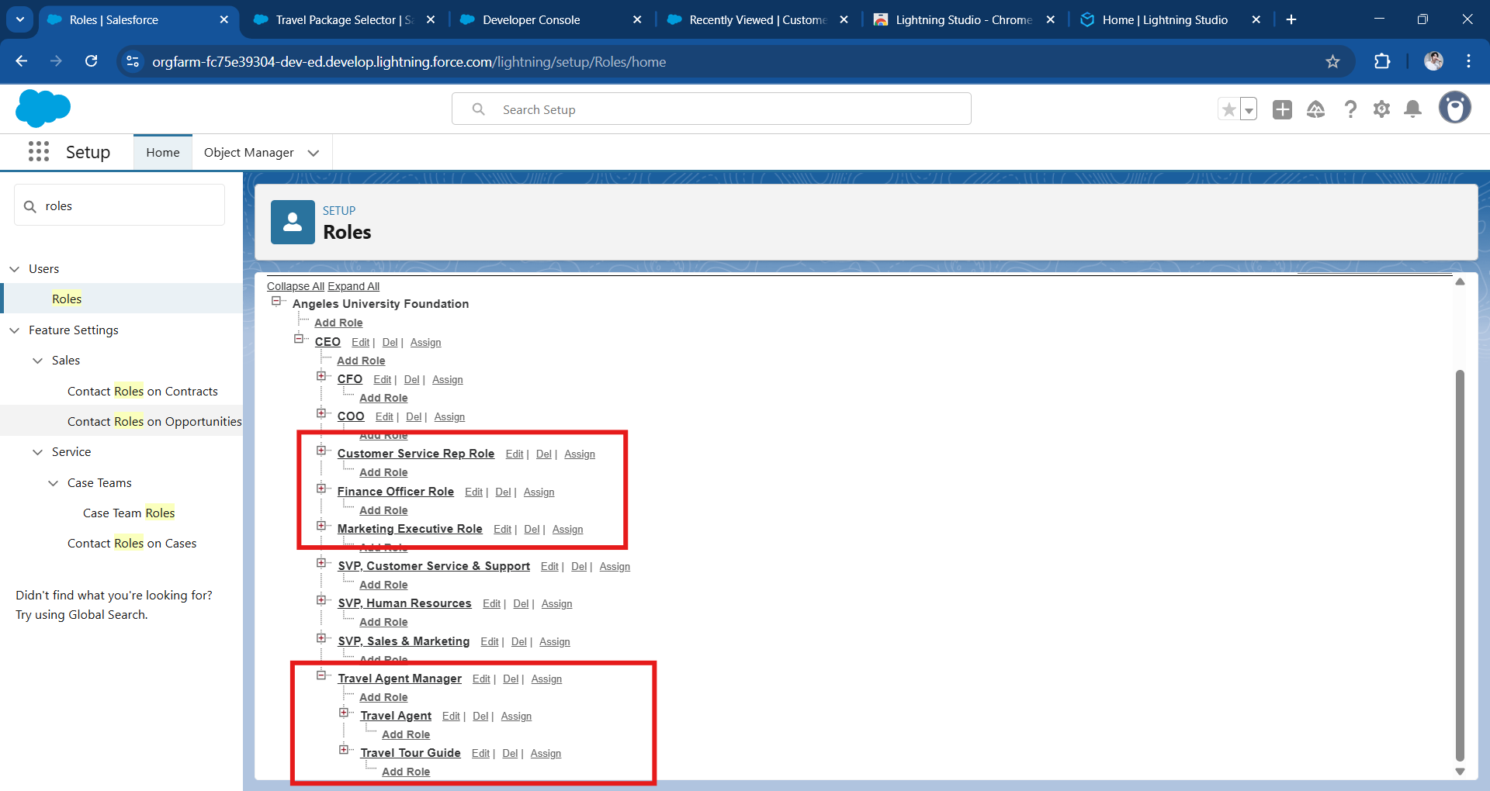

### 

### **Reports and Dashboards**

* Reports: Revenue, Top Packages, Pending Payments, Employee Role Breakdown.

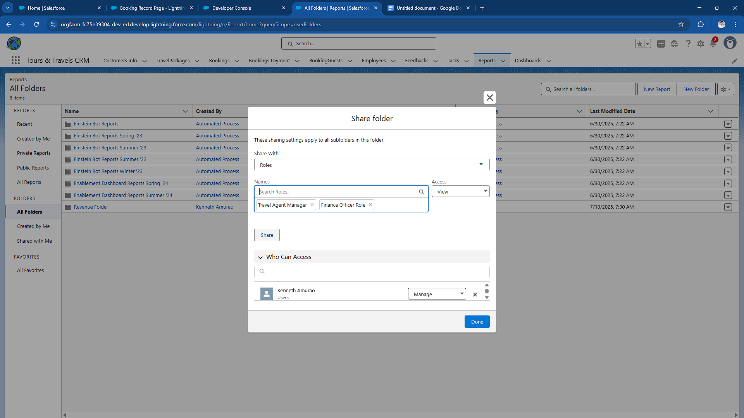

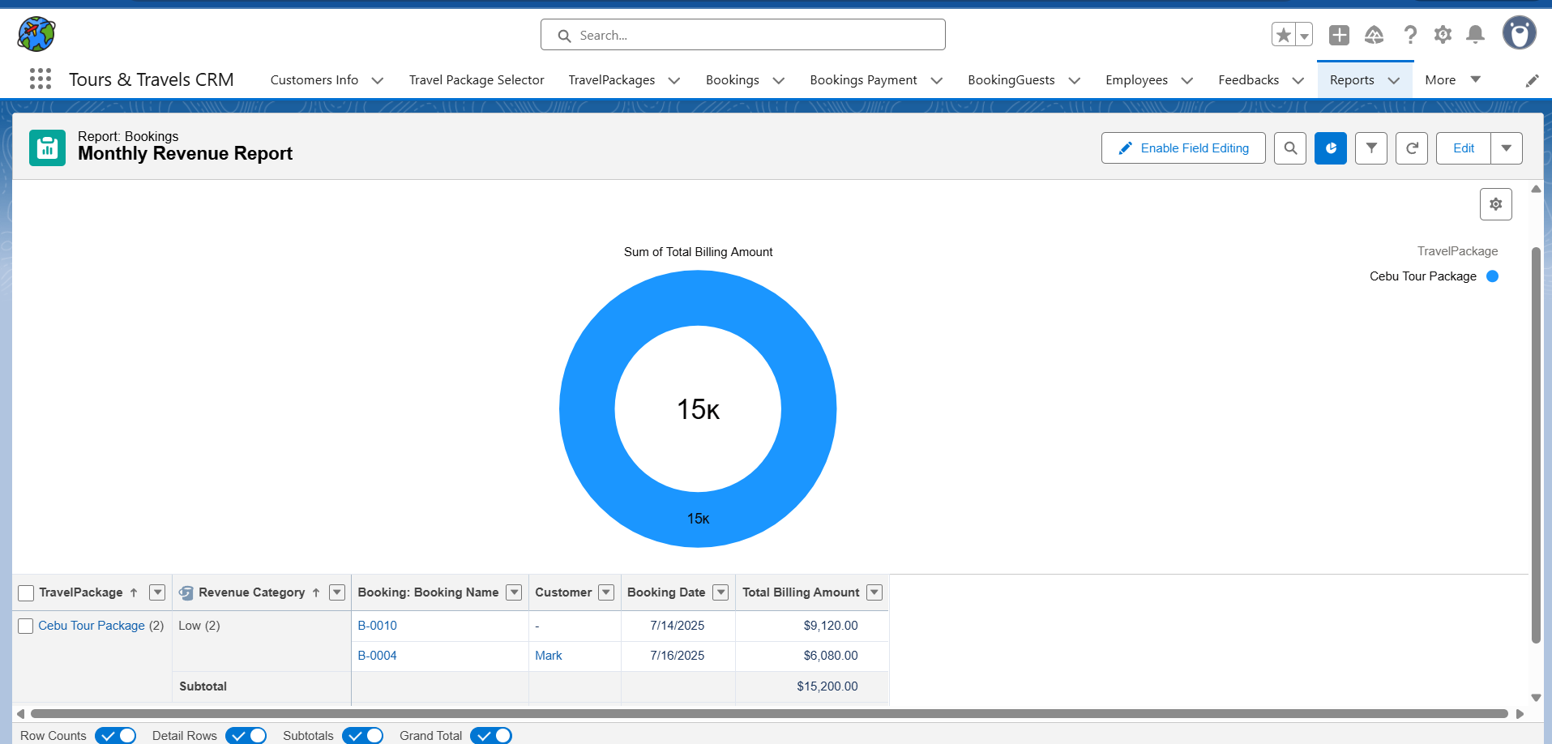

Note: Create a “share folder” first, where you can assign a specific role and store the created report.

* Dashboards: Monthly Revenue, Booking Trends, Package Demand.

## 

Note: If you Edit or Create a Dashboard you can customize you charts through add “widgets” KPI’s based on the created from “Reports”

## 

## 

## 

## 

## 

## 

## 

## **Phase 4: Data Migration, Testing & Security**

### **Data Loading Process**

To bring existing data into the CRM, the **Salesforce Data Import Wizard** was used due to its simplicity and support for standard and custom objects. This tool allowed a user-friendly, guided process for importing:

* **Objects Migrated:** Customer__c, TravelPackage__c, and Employee__c.
* Each CSV file contained a minimum of 20 records with clean data.
* Fields were carefully mapped to ensure accurate data alignment with the corresponding Salesforce fields.

Here is the sample Data Loading Process:

Customer Info CSV import wizard

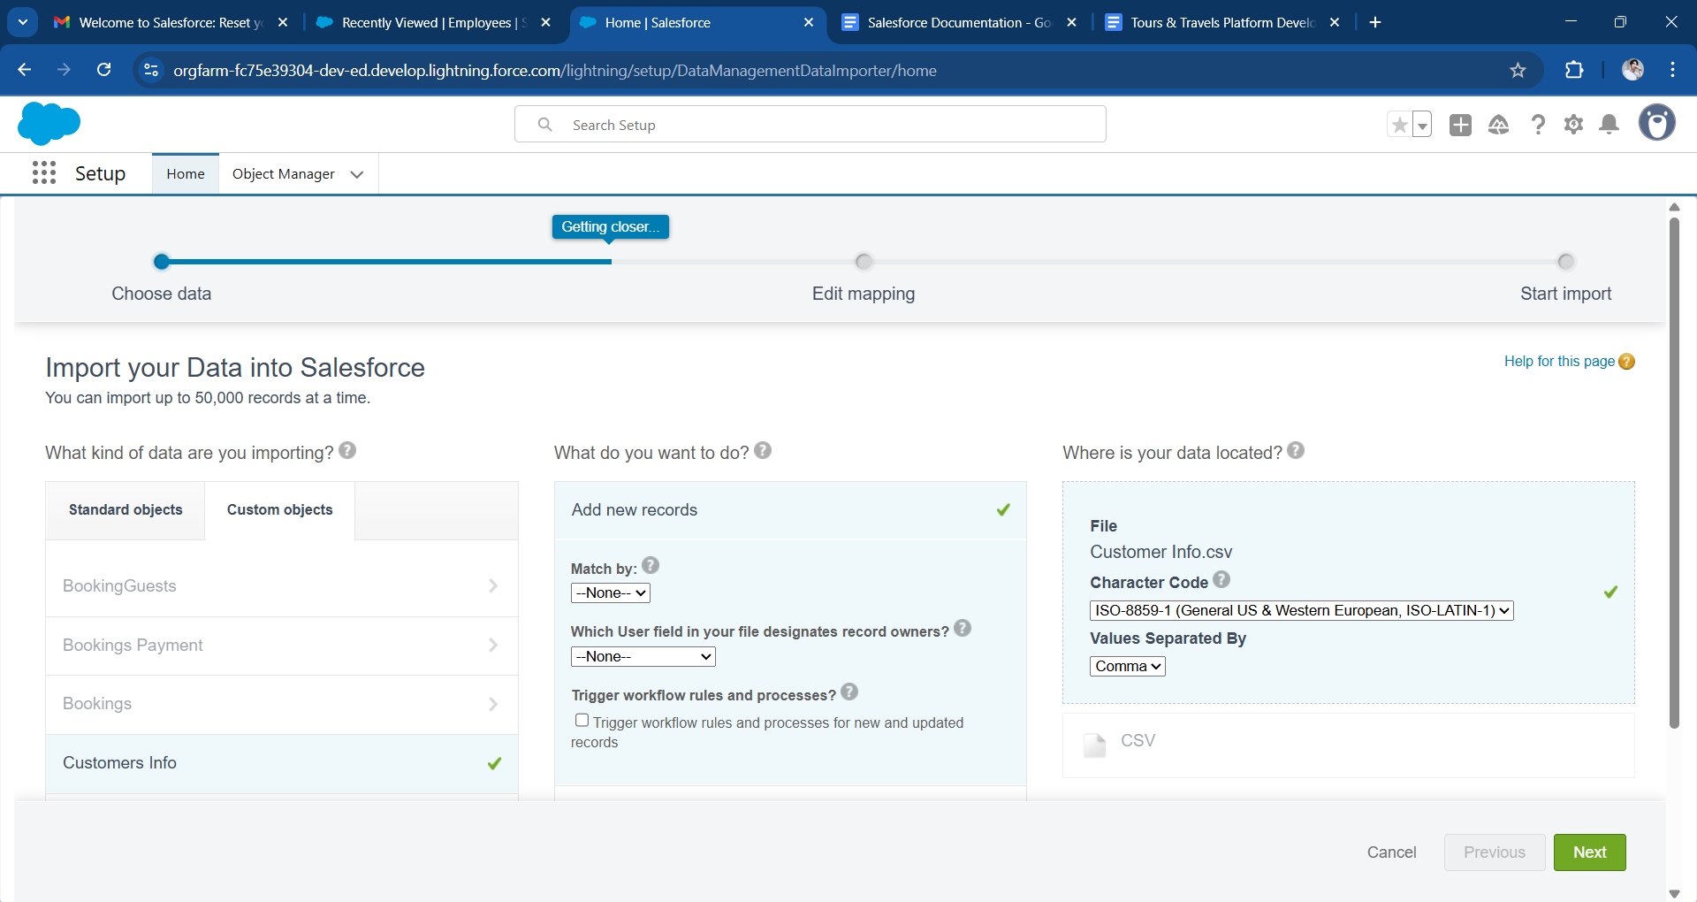

Import Map Field

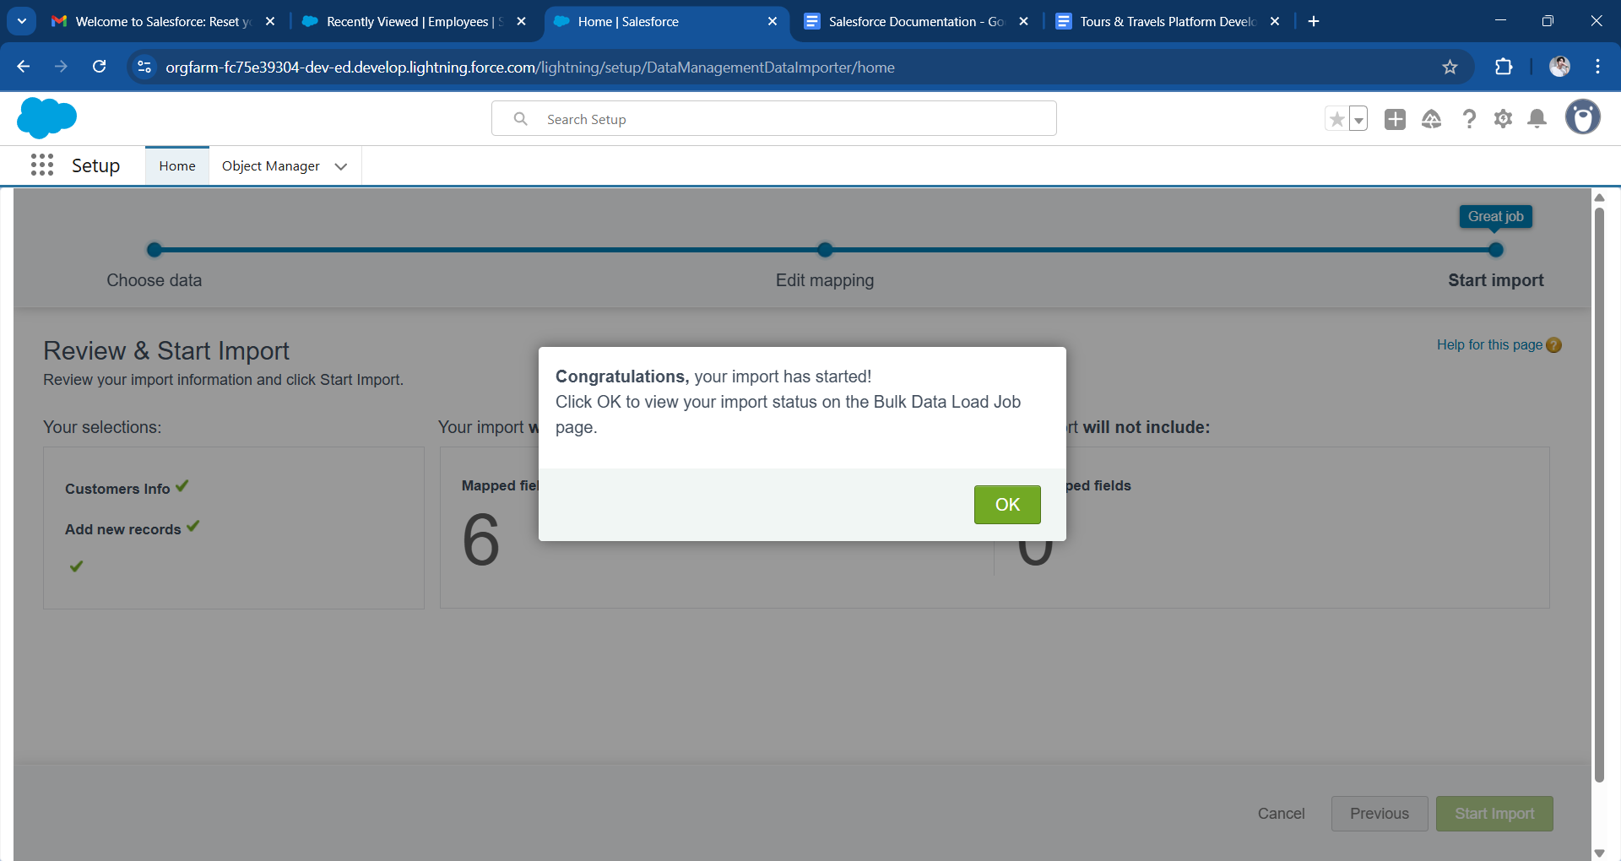

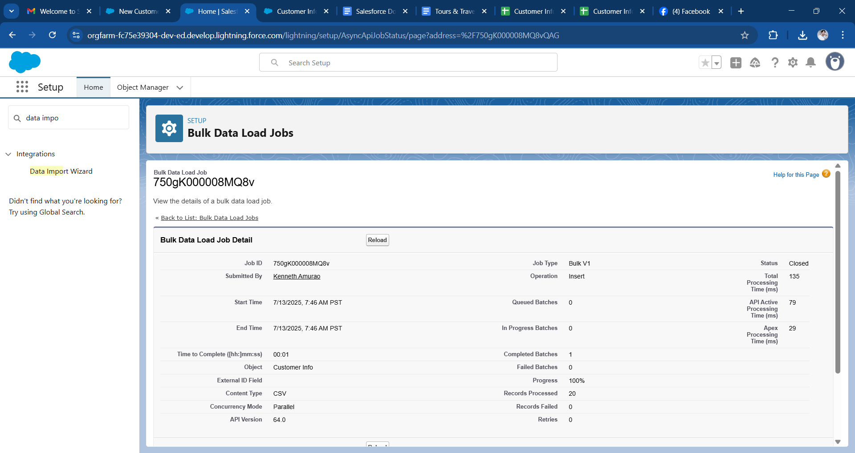

Milestone proof activity completed minimum 20 records for (Customer_Info__c, TravelPackage__c, and Employee__c.)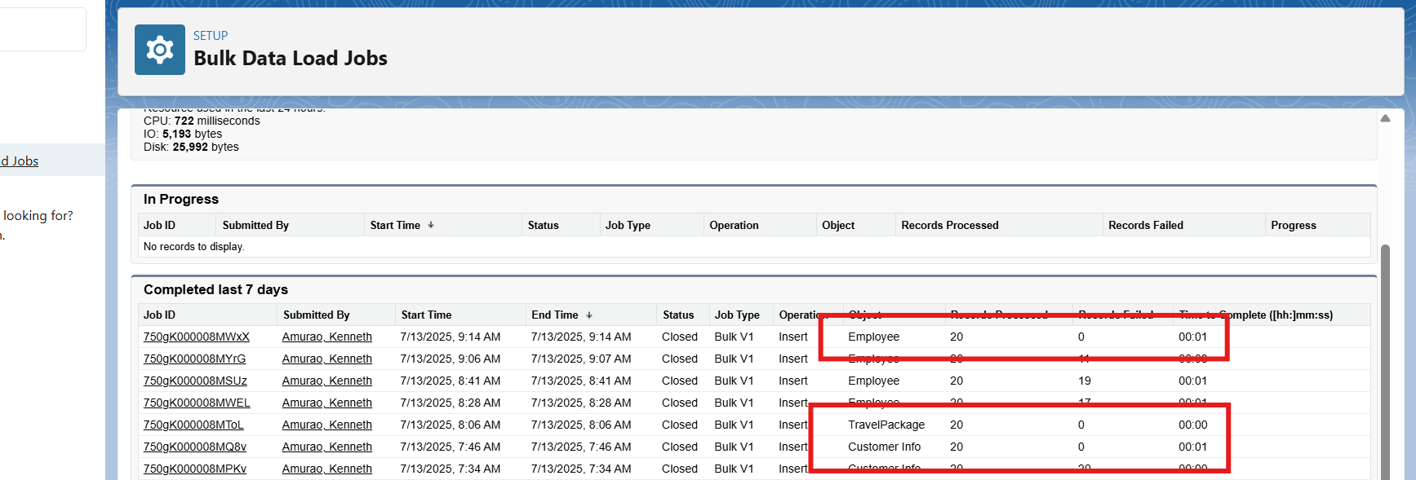

After import, the integrity of records was verified by reviewing the record list views and sample record detail pages.

Note: After clicking “View Record” it will automatically download imported record

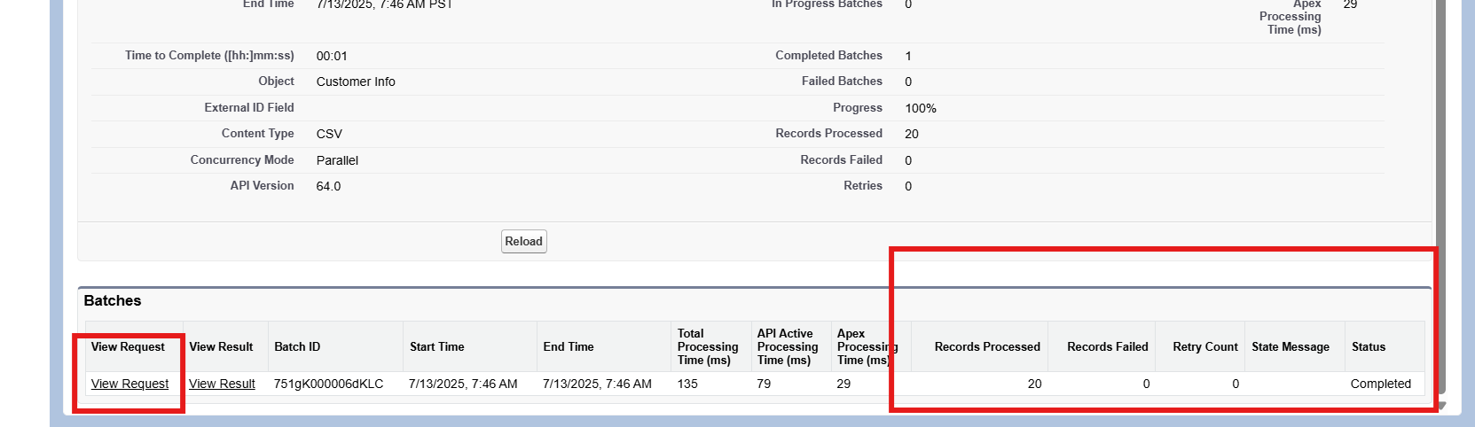

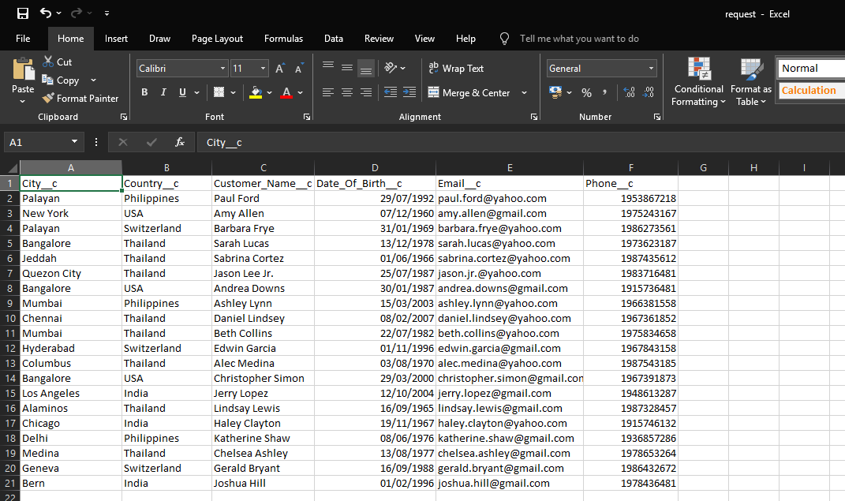

### 

### **Security Implementation**

To protect business-sensitive information and ensure proper user access:

* **Field History Tracking:** Enabled for key fields on Booking__c and TravelPackage__c to monitor changes over time. This allows audit trails for tracking who changed what and when.

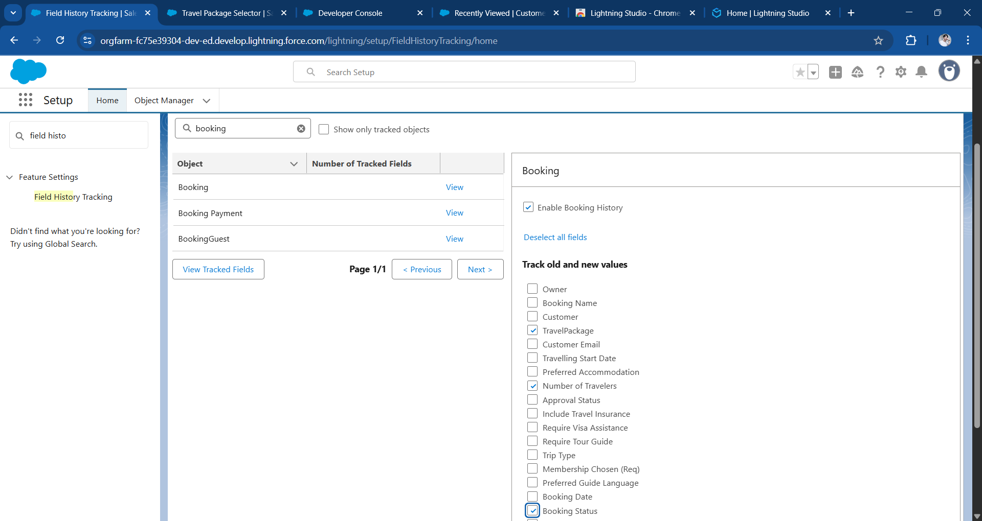

* **Duplicate Rules & Matching Rules:** Created on the Customer__c object to prevent duplicate entries based on unique combinations of Email and Phone.

Custom Matching Rule

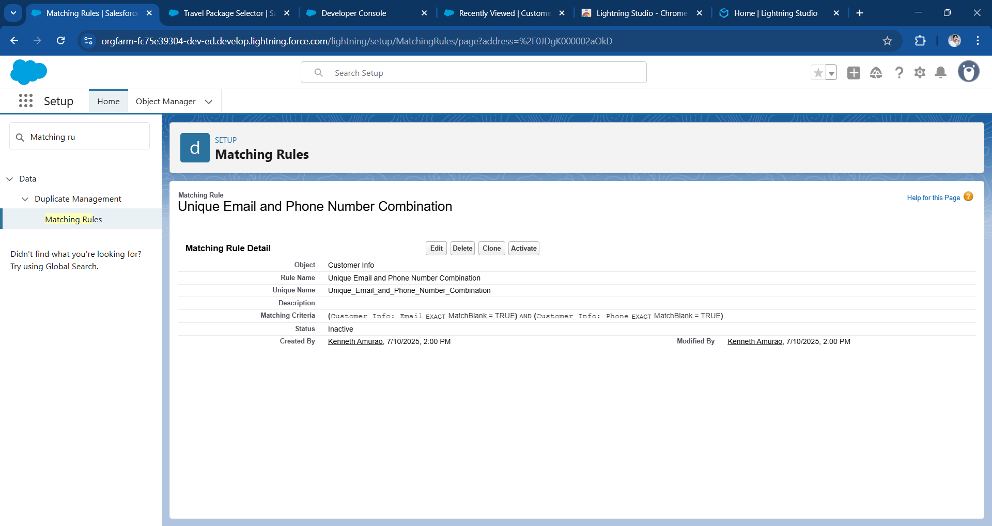

Duplication Rule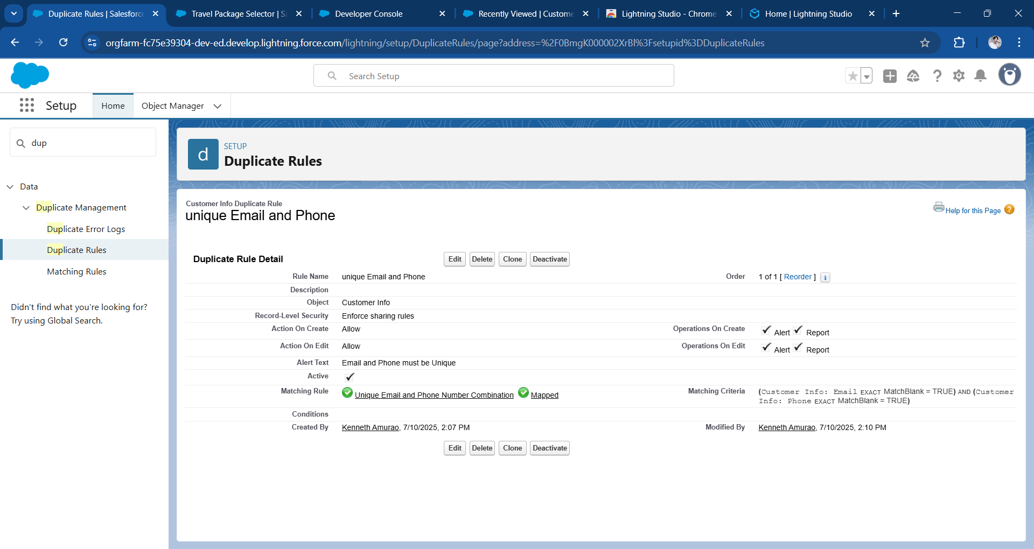

* **Profiles & Roles:** Users were assigned to predefined profiles such as Travel Agent, Finance Officer, and Tour Guide. Roles were used to determine visibility and record-level access.

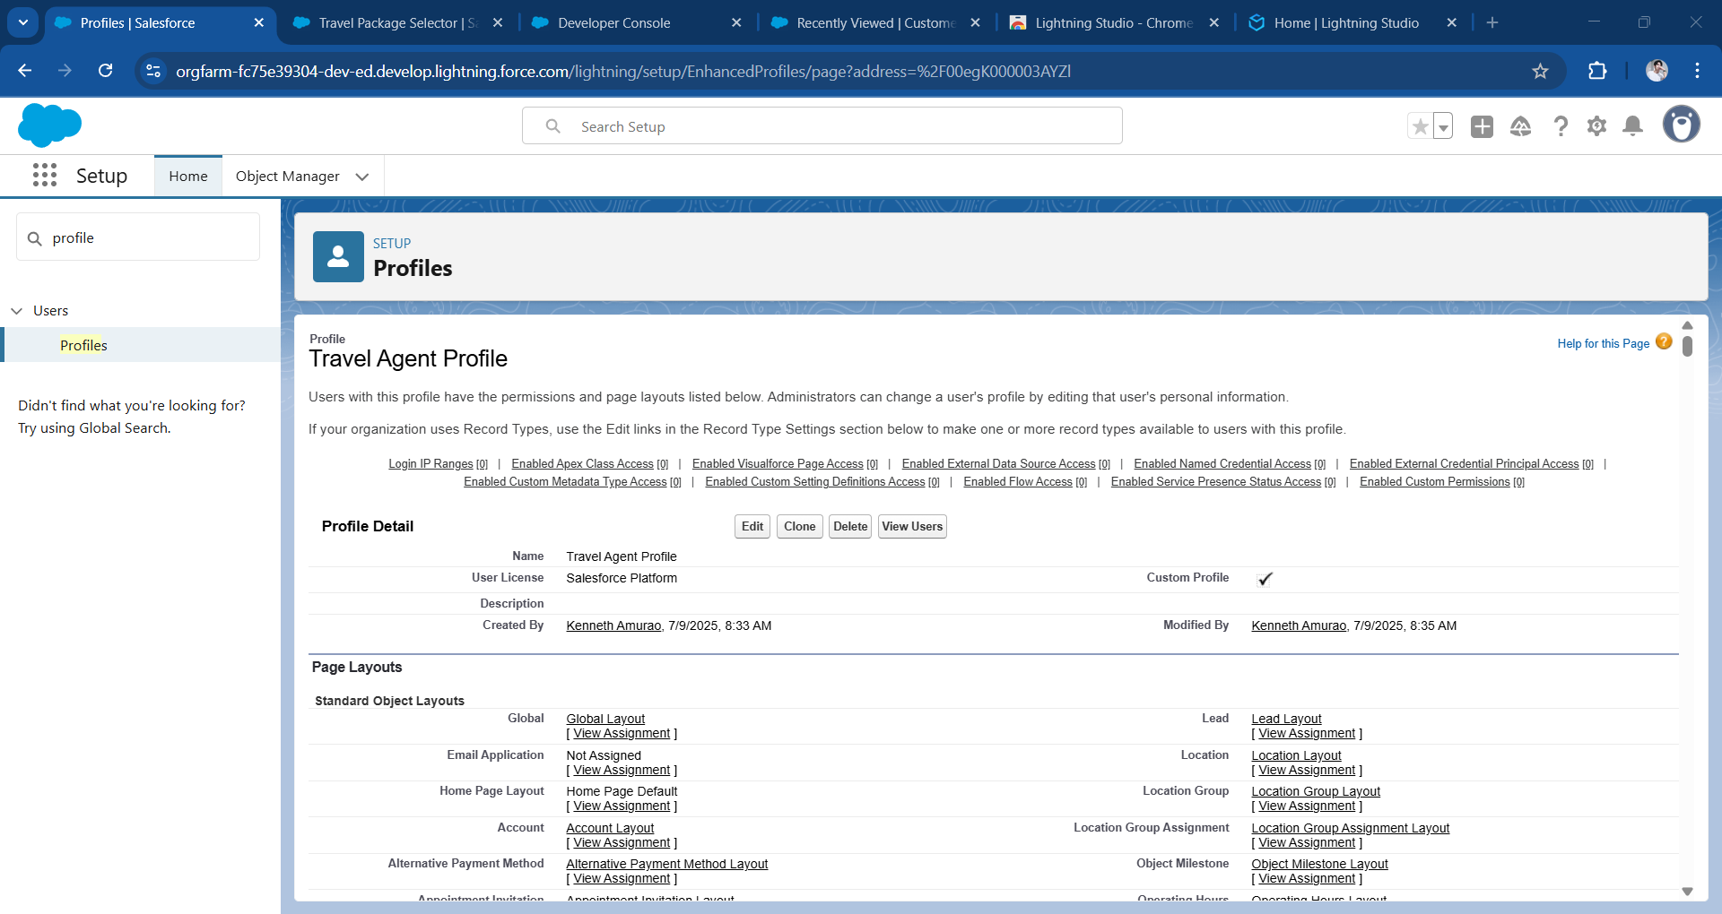

* **Permission Sets:** Used to extend object access for specific users (e.g., Travel Agent Manager needing report access) without changing their base profile.

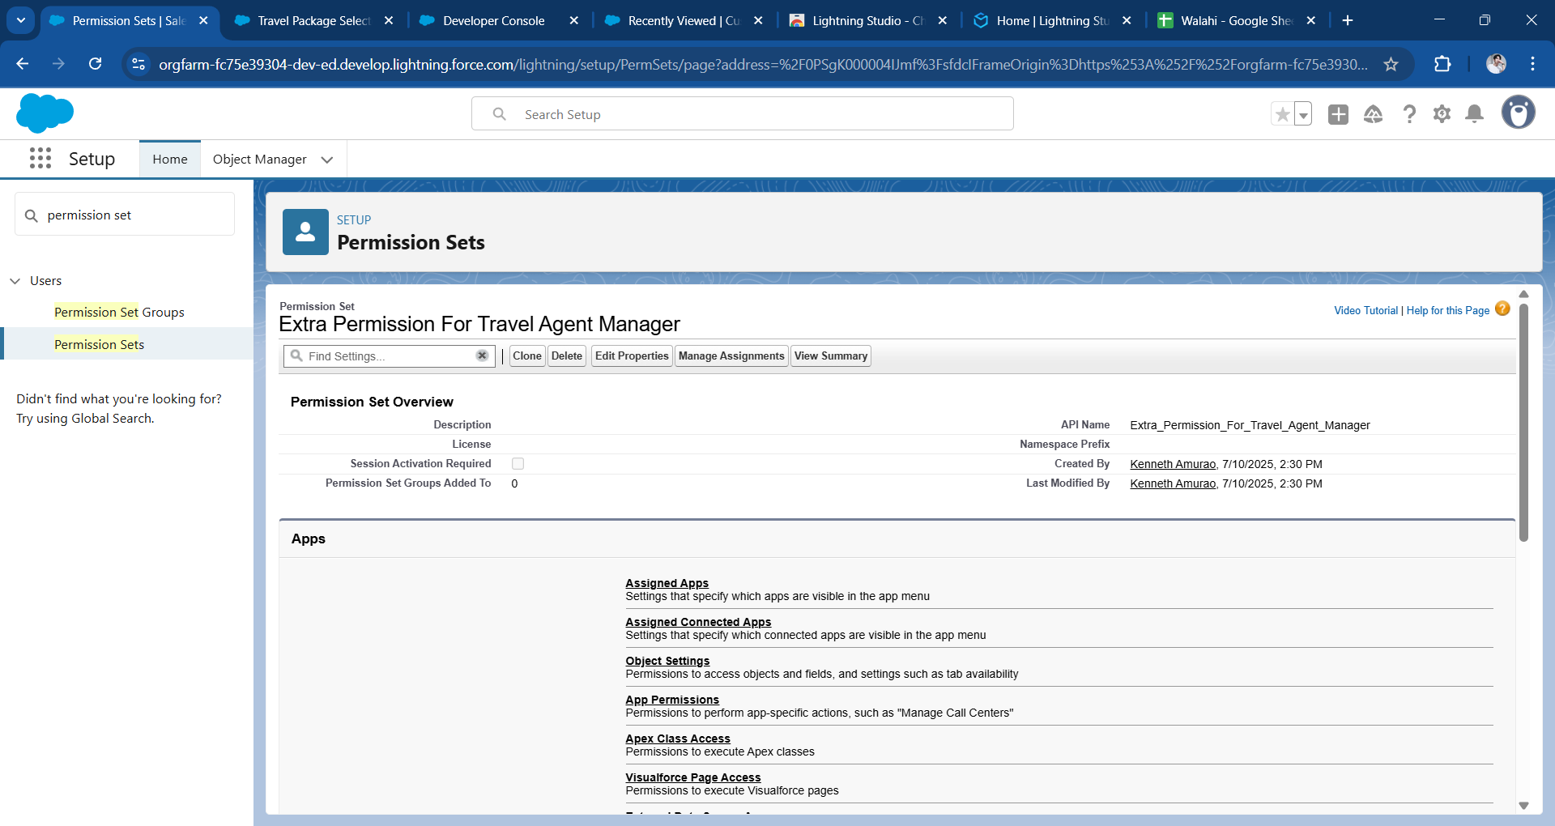

* **Sharing Rules:** Configured to share customer records automatically with Tour Guide roles based on their association with bookings.

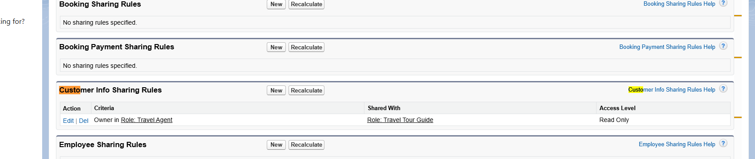

### 

### **Test Class Creation**

* **Apex Test Class:** A test class named BookingTriggerTest was developed to verify the logic inside Booking triggers and handlers. The class inserted mock records and confirmed that associated BookingGuest__c and BookingPayment__c records were automatically created.
* **Challenges and Error:**  The biggest challenge is that some of the fields given in Milestone 4 are not aligned with the code provided in BookingTriggerHandler.apxc and BookingTriggerTest.apxc. Some of the errors are in the BookingTriggerTest.apxc file, where certain fields are not properly defined in Customer_Info__c and Membership_Chosen__c. For example, I encountered a "Missing Date_Of_Birth__c" error on BookingTriggerTest.apxc. To fix this, I added the code: Date_Of_Birth__c = Date.today().addYears(-30);
* **Coverage:** More than 90% code coverage was achieved across Apex triggers and classes.

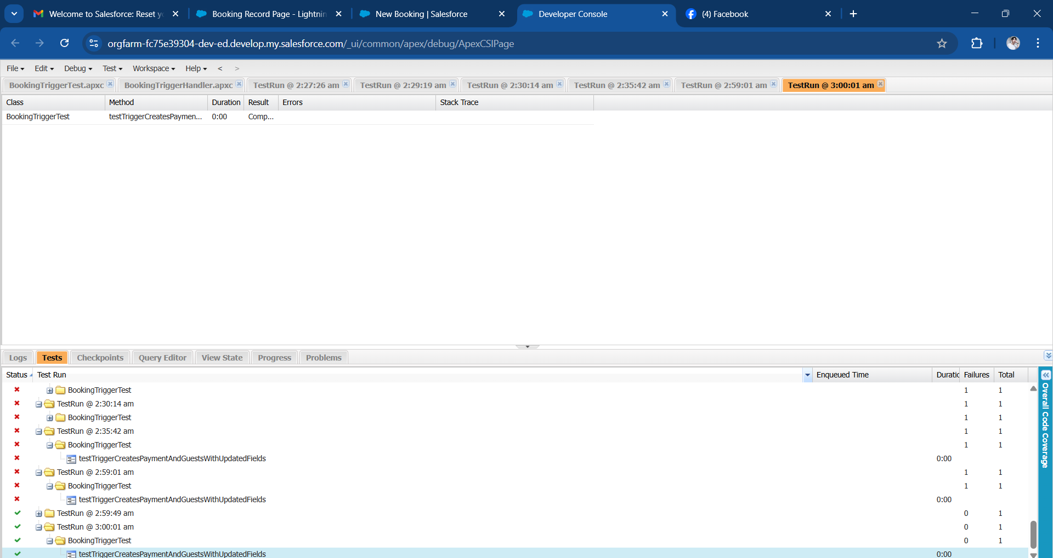

BookingTriggerTest.apxc

@isTest

private class BookingTriggerTest {

@isTest

static void testTriggerCreatesPaymentAndGuestsWithUpdatedFields() {

// Create test customer

Customer_Info__c customer = new Customer_Info__c(

Name = 'John Doe',

Email__c = 'annapurna@gmail.com', // enter your valid email address here

Phone__c = '1234567890',

Date_Of_Birth__c = Date.today().addYears(-30)

);

insert customer;

// Create a Travel Package

TravelPackage__c packageRec = new TravelPackage__c(

Name = 'European Delight',

Country__c = 'India',

Price_Per_Person__c = 2000,

Duration_in_Days__c = 3,

Places_Covered__c = 'Paris, Rome, Barcelona'

);

insert packageRec;

// Create a test Booking record

Booking__c booking = new Booking__c(

Number_of_Travelers__c = 3,

Booking_Status__c = 'Pending',

Travelling_Start_Date__c = Date.today().addDays(10),

TravelPackage__c = packageRec.Id,

Membership_Chosen_Req__c = 'Gold',

Preferred_Accommodation__c = 'Guest House',

Customer_Info__c = customer.Id,

//Customer__c = customer.Id, // fixed field name

Customer_Email__c ='annapurna@gmail.com', // enter a valid email address here

Booking_Date__c = Date.today() // added required field

);

Test.startTest();

insert booking; // Trigger will fire here

Test.stopTest();

// Validate Booking_Payment__c creation

List<Booking_Payment__c> payments = [

SELECT Id, Booking__c, Payment_Status__c

FROM Booking_Payment__c

WHERE Booking__c = :booking.Id

];

System.assertEquals(1, payments.size(), 'One payment record should be created.');

System.assertEquals('Pending', payments[0].Payment_Status__c, 'Default Payment Status should be Pending.');

// Validate BookingGuest__c creation

List<BookingGuest__c> guests = [

SELECT Id, Booking__c, Name

FROM BookingGuest__c

WHERE Booking__c = :booking.Id

];

System.assertEquals(3, guests.size(), 'Three BookingGuest records should be created.');

System.assertEquals('Guest 1', guests[0].Name, 'Guest naming should follow convention.');

}

### 

### **Testing Execution**

**Test Case 1:** Ensure that a new Customer record can be added successfully when all required fields are filled.

**Test Steps:**

* Open the Customer module or object page.
* Enter values for all mandatory fields.
* Click on the **Save** button

**Expected Result:**

* The Customer record should be created and stored without any errors.
* The newly added record should be visible in the list of existing Customers.

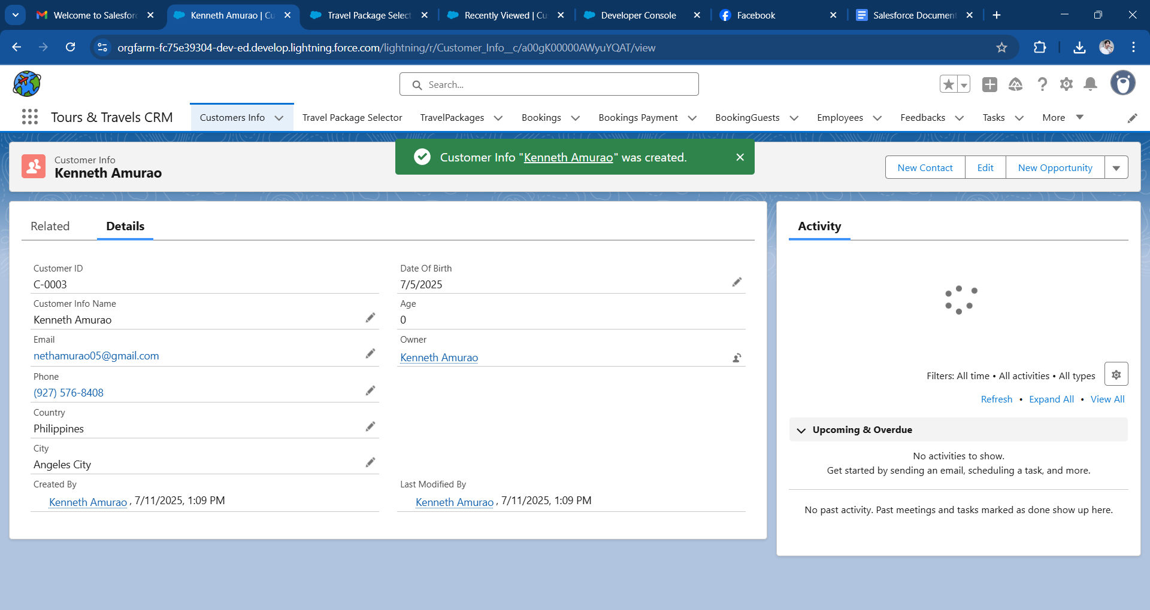

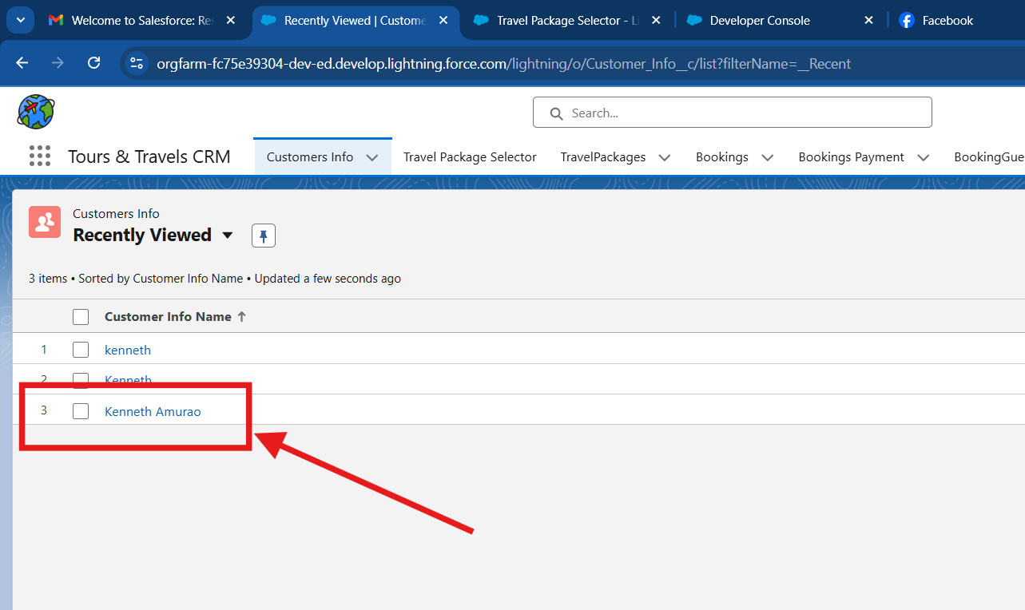

**Test Case 2**: Confirm that a Booking can be successfully recorded when all required information is provided.

**Test Steps:**

* Go to the Booking object interface.
* Complete all necessary fields with appropriate values.
* Click **Save** to submit the form.

**Expected Result:**

* A new Booking entry should be created and saved properly.
* The record should show up on the Booking List view.
* A corresponding entry should automatically be created in the Booking Payments object with the Payment Status set to "Pending".
* A number of BookingGuest entries equal to the "Number of Travellers" specified in the Booking should also be created and linked to the Booking record.

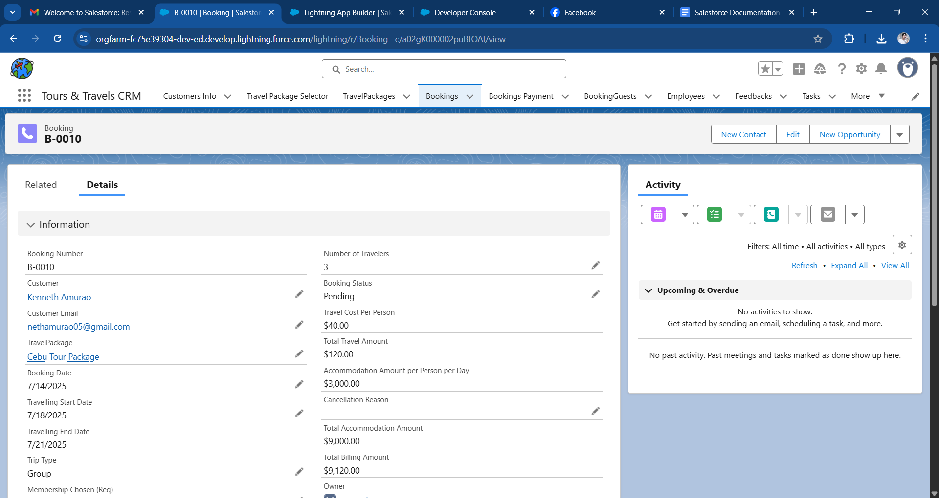

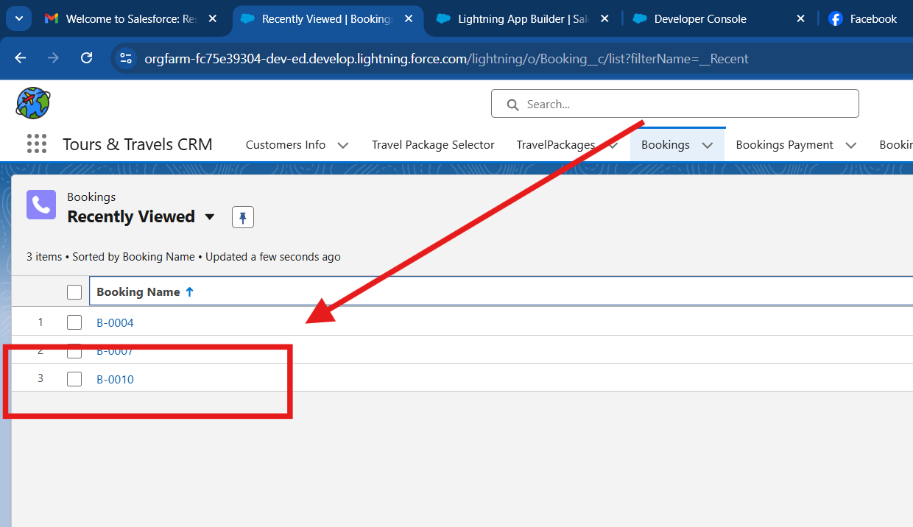

**Test Case 3:** Verify that when the Payment Status of a Booking Payment record is changed to "Completed", the related Booking record updates to "Confirmed", and the customer is notified via email.

**Test Steps:**

* Navigate to the Booking Payment object page.
* Change the **Payment Status** field value to "Completed".
* Save the changes.

**Expected Result:**

* The Booking Payment record should be updated successfully.
* The corresponding Booking record should automatically reflect a "Confirmed" status.
* An email should be sent to the customer confirming the Booking and successful payment.

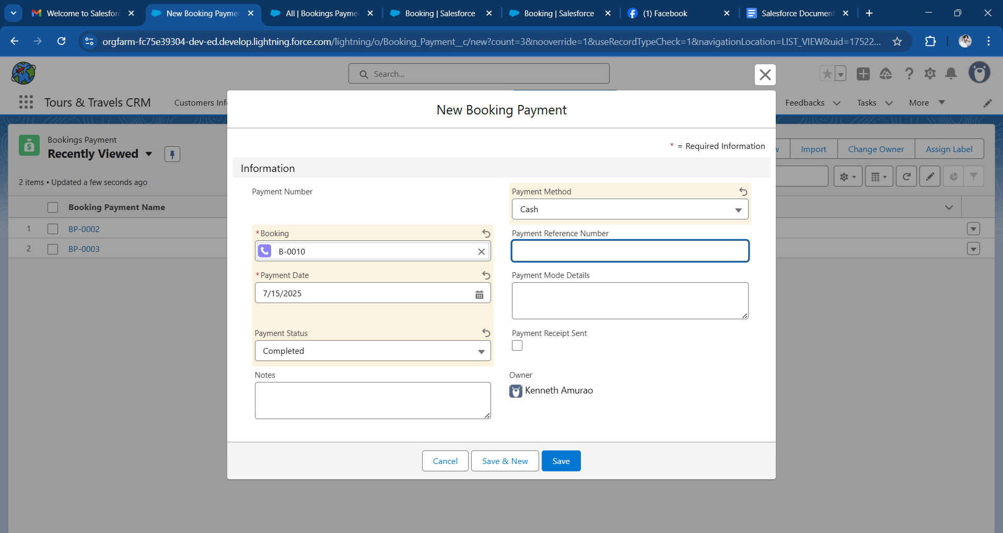

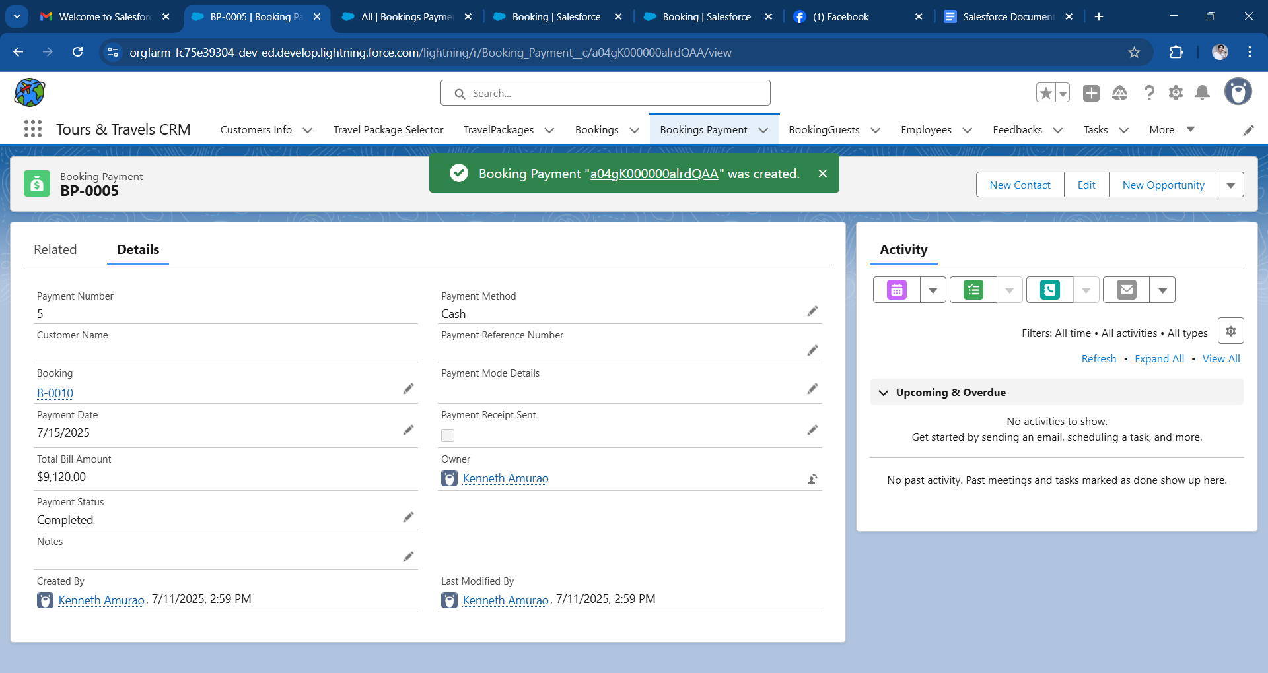

### 

### **Test Case 4: Booking Creation With Employee TourGuide**

**Objective:**

* Prevent booking with a past travel start date.

**Test Steps:**

* Navigate to the Booking object.
* Create a new booking.
* Fill other required fields
* Checked the “Required” Tou Guide”.
* Create or add Existing Employee and click Save.

**Expected Result:**

* Successful Banner Appear then te Guide employee assigned will booking details

**Validation Area:**

* Lookup Filter on Emplyee__c field in booking, Role and Availability

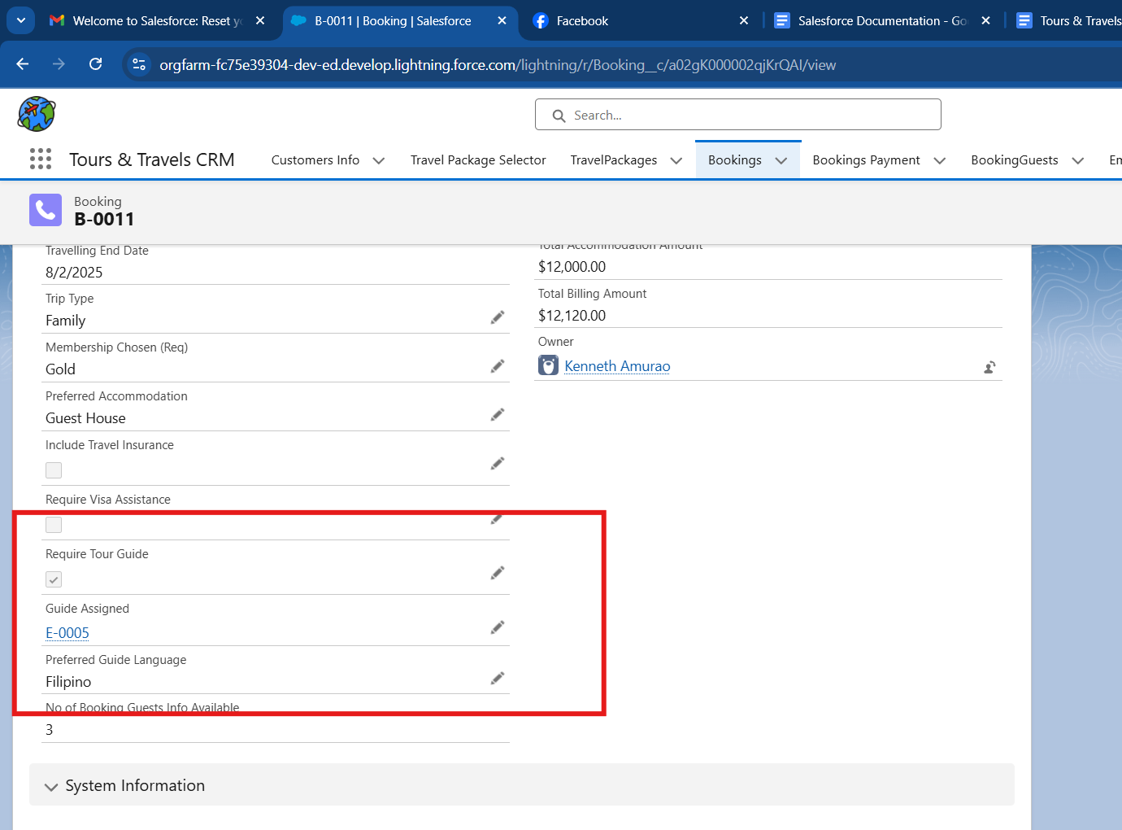

### **Test Case 5: Duplicate Customer Creation**

**Objective:**

* Prevent creation of customers with same phone and email.

**Test Steps:**

* Create a Customer Info record with Email = Gabby@gmail.com and Phone = 1234567890.
* Try creating another customer with the same email and phone.

**Expected Result:**

* Error: *"Email and Phone must be Unique."*
* **Validation Area:** Duplicate rule, Matching rule.

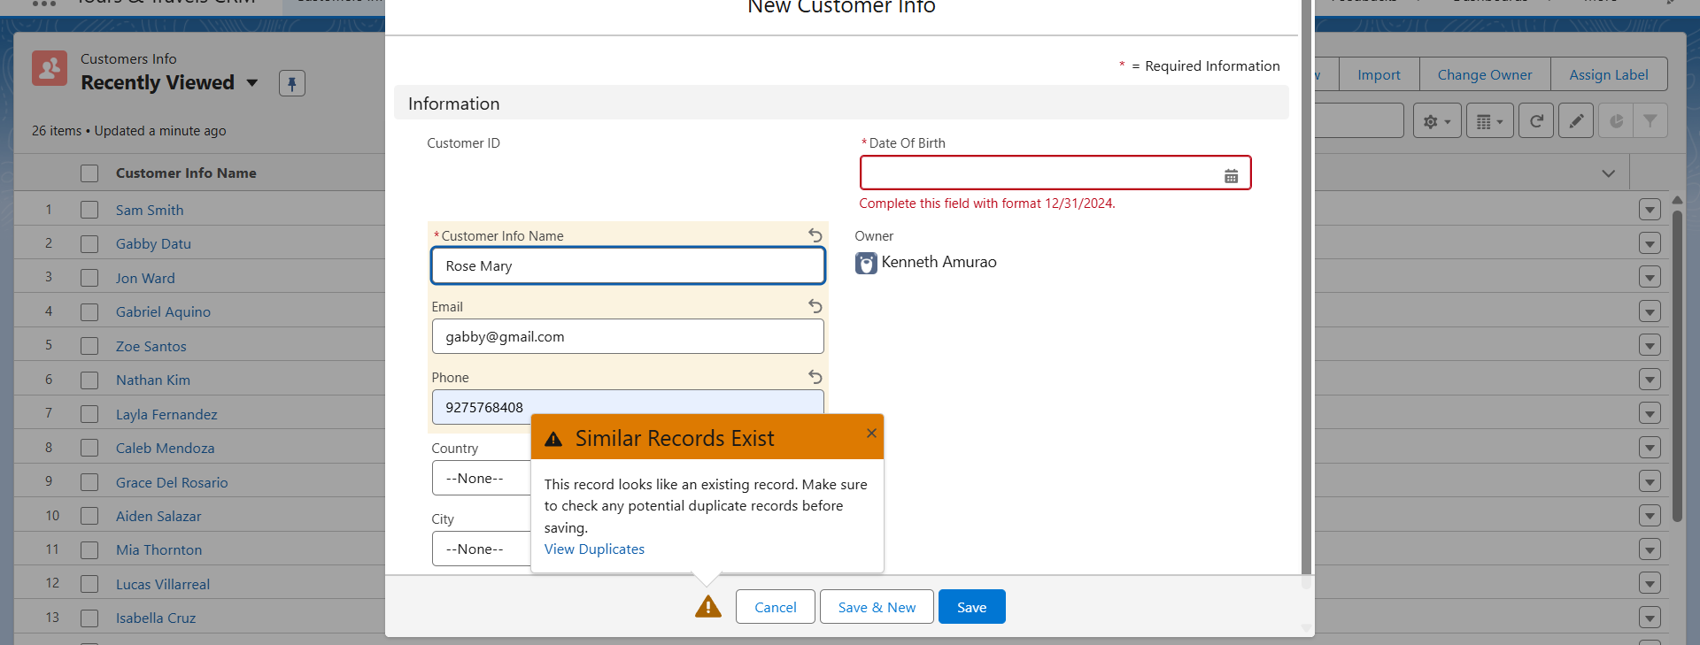

**Test Case 6: Dynamic Field Visibility**

**Objective:**

* Verify dynamic forms hide/show fields.

**Test Steps:**

* Open a Booking record with Booking Status = Cancelled.
* Check if *Cancellation Date*, *Cancel Confirmation*, *Approval Status* are visible.

**Expected Result:**

* Fields are visible only when status = Cancelled.

**Validation Area:**

* Dynamic Forms.

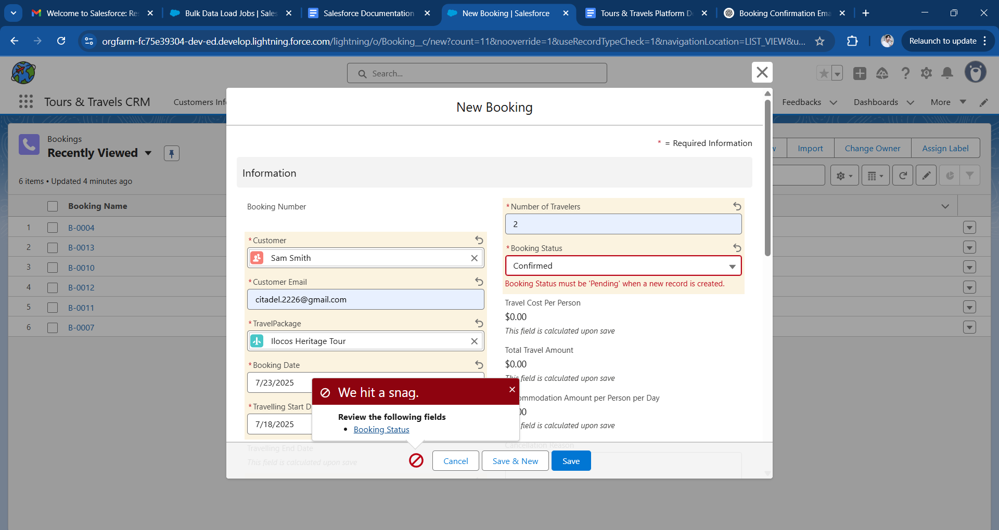

**Test Case 7: Trip Cancellation Approval Workflow**

**Objective:**

* Validate approval process when booking is cancelled.

**Test Steps:**

* Update an existing Booking record:
* Booking Status = Cancelled
* Cancel Confirmation = True
* Submit the record for approval.

**Expected Result:**

* + Approval request sent to manager.
  + Email sent upon approval or rejection.

**Validation Area:** Approval process, email templates.

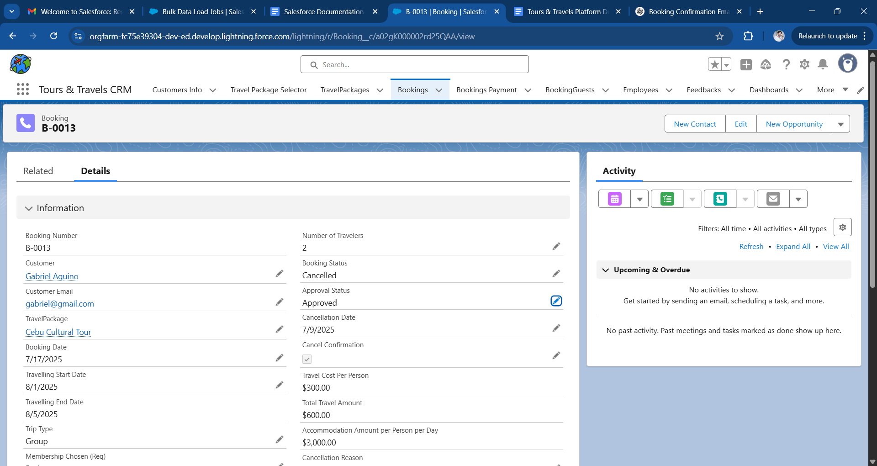

**Phase 5: Deployment, Documentation & Maintenance**

### **Deployment Strategy**

The deployment methodology for the Tours & Travels CRM system was executed through the use of **Change Sets**, a widely accepted and secure method in the Salesforce ecosystem. This process entailed:

* **Preparation of Outbound Change Sets**: All essential metadata components—including custom objects, fields, automation flows, Apex classes, analytical reports, dashboards, and user access configurations (profiles and permission sets)—were aggregated and packaged within the source environment.
* **Transmission to Target Environment**: The prepared change set was transmitted to the designated target instance, whether production or staging.
* **Validation and Execution**: Prior to final deployment, a comprehensive validation step was conducted to confirm that all required dependencies were included. Once validated, the components were successfully deployed.

### **Maintenance and Monitoring Plan**

To ensure continuous operational integrity and system resilience, the following monitoring and maintenance protocols are established:

* **Audit Log Supervision**: Login histories and setup audit trails are reviewed on a regular basis to detect unauthorized access or administrative changes.
* **Scheduled Job Oversight**: The statuses of automated jobs, including both Schedulable and Batch Apex executions, are monitored through the Apex Jobs interface.
* **Data Quality Assurance**: Duplicate management rules and validation rules are utilized to ensure the integrity and reliability of entered data.
* **Field History Analysis**: Key object fields (such as those in Bookings and Travel Packages) are tracked to audit data changes and facilitate debugging.
* **Access Control Reviews**: Profiles, Permission Sets, and Role assignments are periodically audited to maintain appropriate data visibility and compliance.

### **Troubleshooting Approach**

In the event of unexpected application behavior or systemic errors, a formalized troubleshooting methodology is employed:

1. **User Issue Documentation**: Collect and analyze user-submitted reports or support tickets detailing the observed issues.
2. **Debug Log Activation**: Enable debug logs for relevant users or classes to trace runtime exceptions and performance bottlenecks.
3. **Automation Failure Inspection**: Examine error logs in Flows and Process Builders to identify failed or misconfigured automation.
4. **Embedded Error Messaging**: Utilize predefined error messages within Flows and Apex logic to guide users and expedite issue identification.
5. **Deployment Diagnostics**: Review validation logs in Change Sets to troubleshoot deployment failures and missing dependencies.

### **Conclusion**

The development and implementation of the Tours & Travels CRM platform on Salesforce comprehensively fulfill the strategic and operational needs of modern travel service providers. From efficient customer onboarding and itinerary bookings to automated approval workflows and payment tracking, the system has proven effective in enhancing organizational efficiency.

By integrating declarative tools such as Flows and Reports alongside programmatic assets like Apex Triggers, Classes, and Lightning Web Components, the solution is both robust and extensible. The modular design ensures adaptability to future business requirements and facilitates potential upgrades such as AI-driven recommendations, chatbot support, and mobile accessibility.

The successful culmination of this project reflects a thorough understanding of Salesforce architecture and development best practices, reinforcing the project's viability for real-world deployment.